**Smart Transit Management System**

**Using Service Now**

**Project Description:**

The Smart Transit Management System is built on the ServiceNow platform to streamline and automate bus service operations. It enables passengers to book and manage tickets, drivers to access schedules, and administrators to oversee buses, routes, and reports. The system leverages ServiceNow’s catalog items, workflows, roles, and reporting features to create a smooth end-to-end solution.

**Skills:**

* **ServiceNow:** Catalog Items, Record Producers, Tables, Workflows, ACLs, Notifications, Reporting**.**
* **Technical:** JavaScript, Glide API, Database Design.
* **Project Skills:** Problem-solving, Requirement Analysis, Documentation, Team Collaboration.

**Mile stone 1: Creating an Update Set**

1. Click on All >> Local Update set

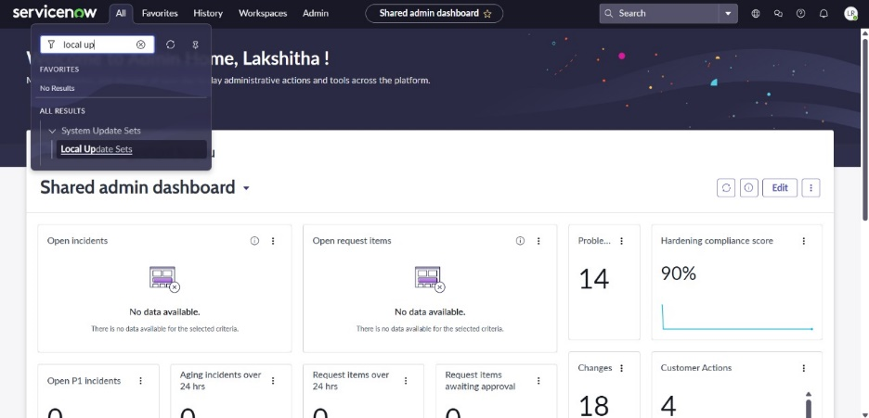

1. Click New

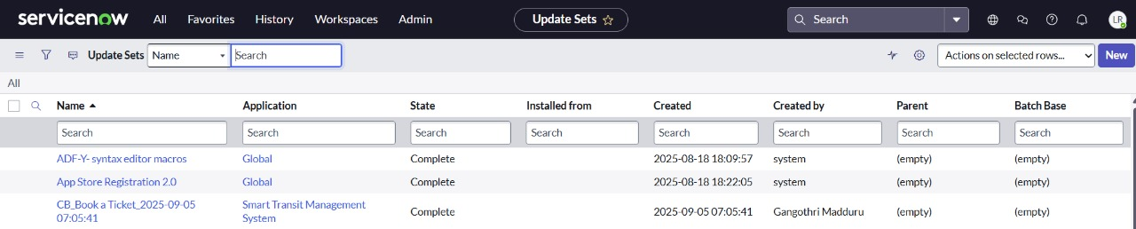

1. Enter the Details Name: Smart Transit Management System >> Click on submit and make current.

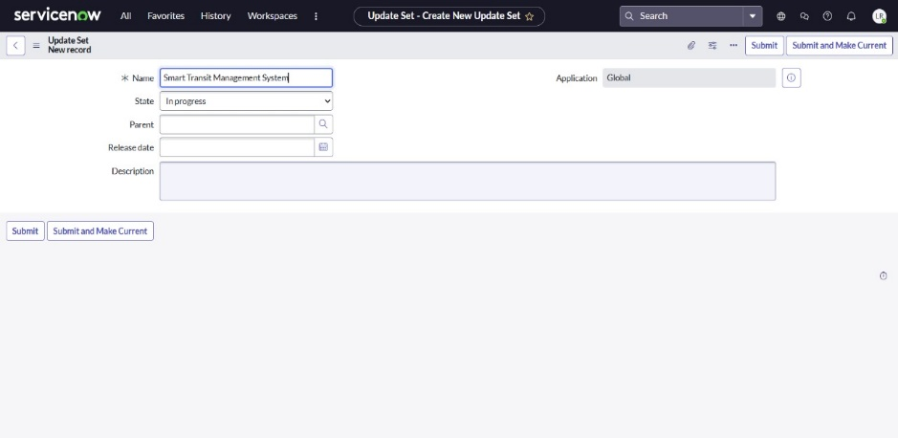

**Mile stone 2: Creating Application**

1.All >> App Engine >> ServiceNow Studio

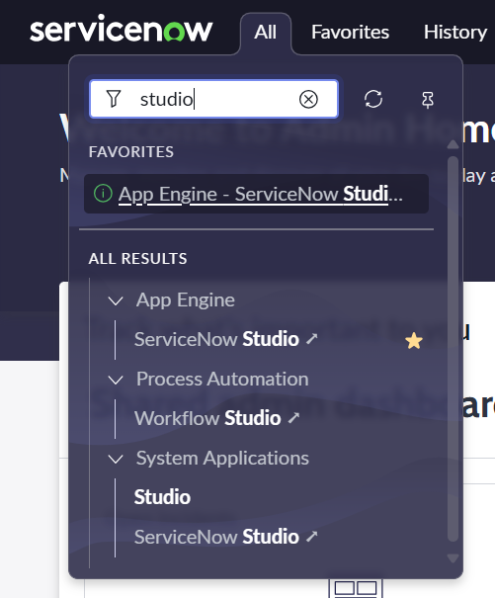

2.Select the Create icon [+] and then select App.

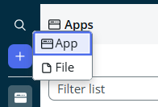

**Name: Smart Transit Management System**

**Description**: A platform to book or cancel tickets, manage routes and schedules, and handle passenger complaints efficiently for smooth transit operations.

3.Select continue

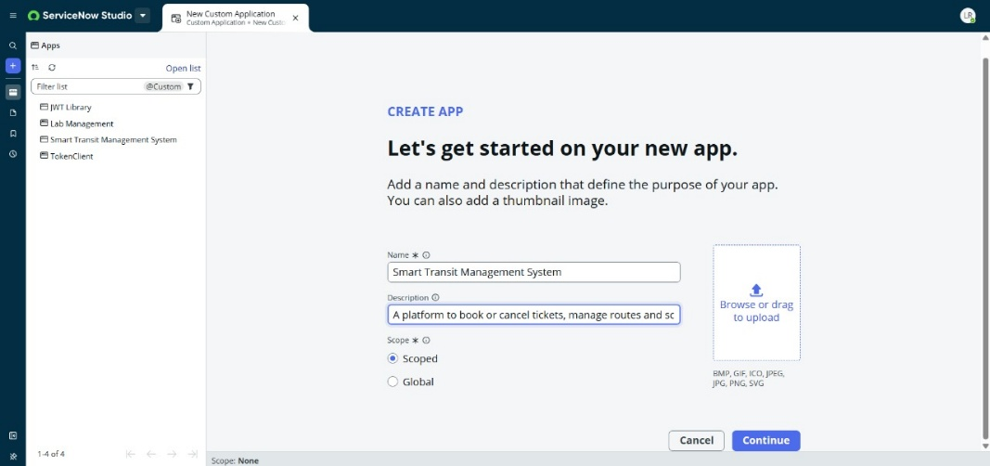

4.Select the Create icon [+] and then select File.

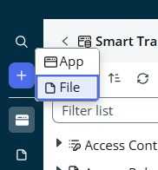

5.Specify the Application the file will belong to: *Smart Transit Management System.*

6.Select Data on the left-side panel.

7.Scroll down and select Table as the file type.

8.Select Continue.

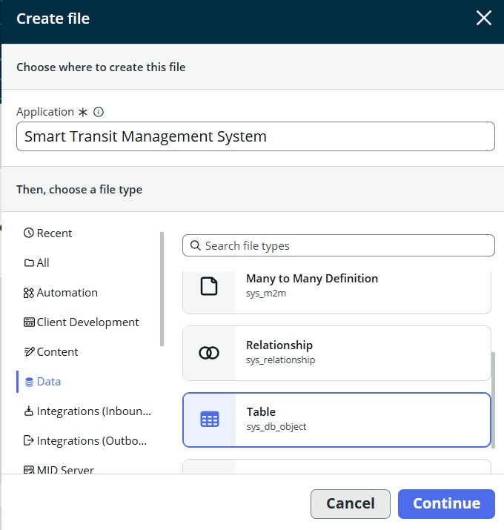

**Mile stone 3: Creating Tables**

**Creation of various tables in ServiceNow**

**Step 1: Open ServiceNow Studio (All -> System Applications -> ServiceNow Studio)**

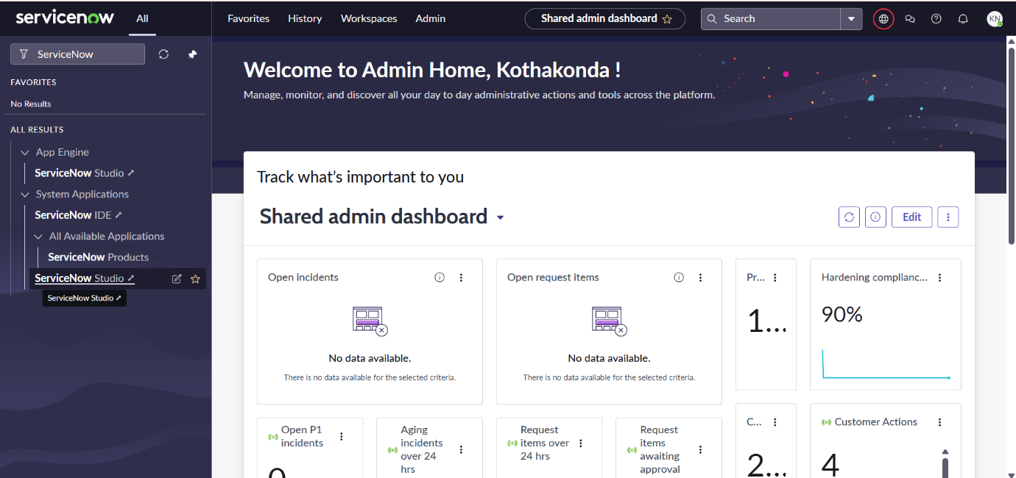

**Step 2: Click on Create (File) and Select your application scope and table(sys_db_object) and click on create.**

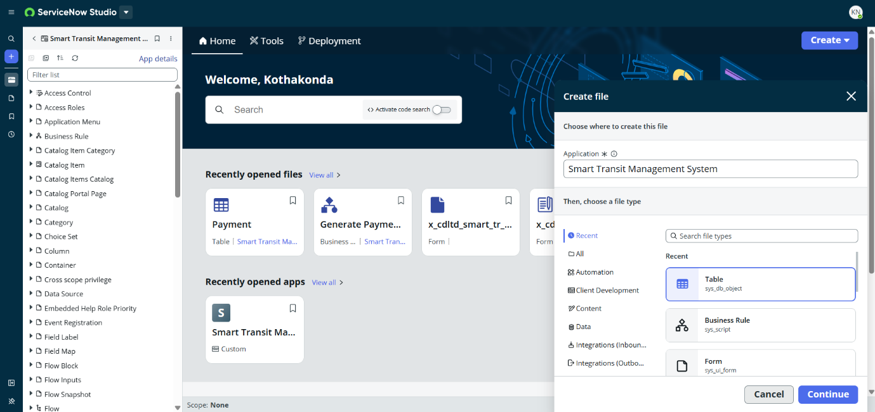

**Step 3: Enter the details of the table that you want to create and click on Submit**

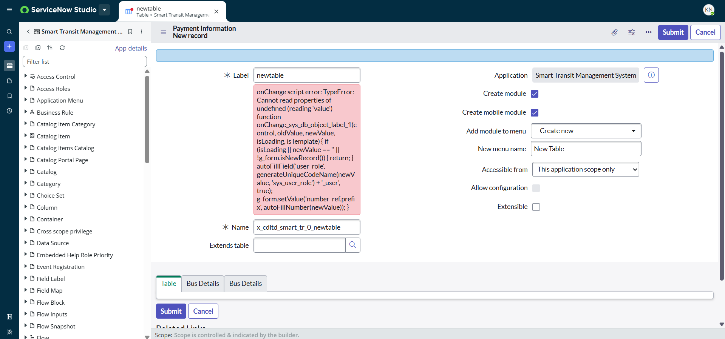

**Step 4: Add the fields in the table by double clicking on the table fields and click on Save**

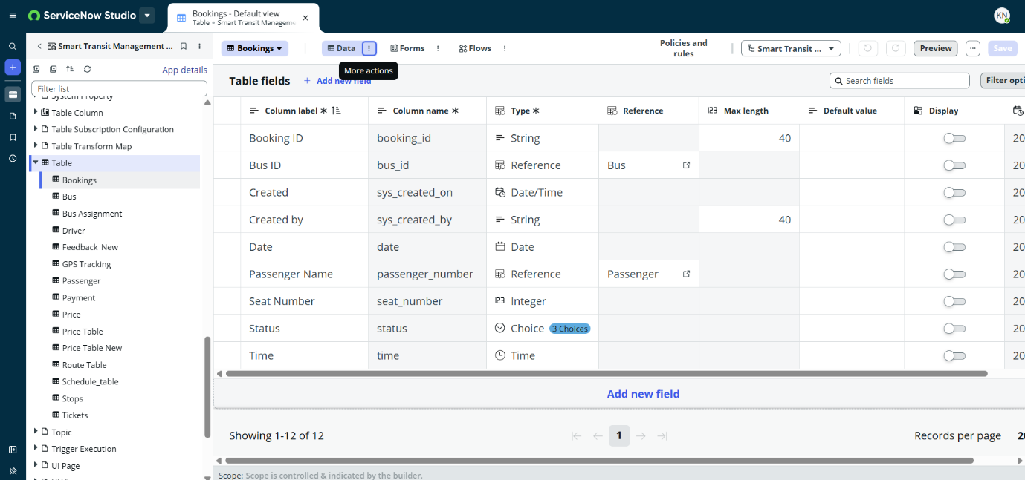

**For this project, we have created multiple tables. The following gives you the details of each table**

**Table 1: Active Bookings**

**This table displays the data of passengers booking status as Pending, Booked or Cancelled.**

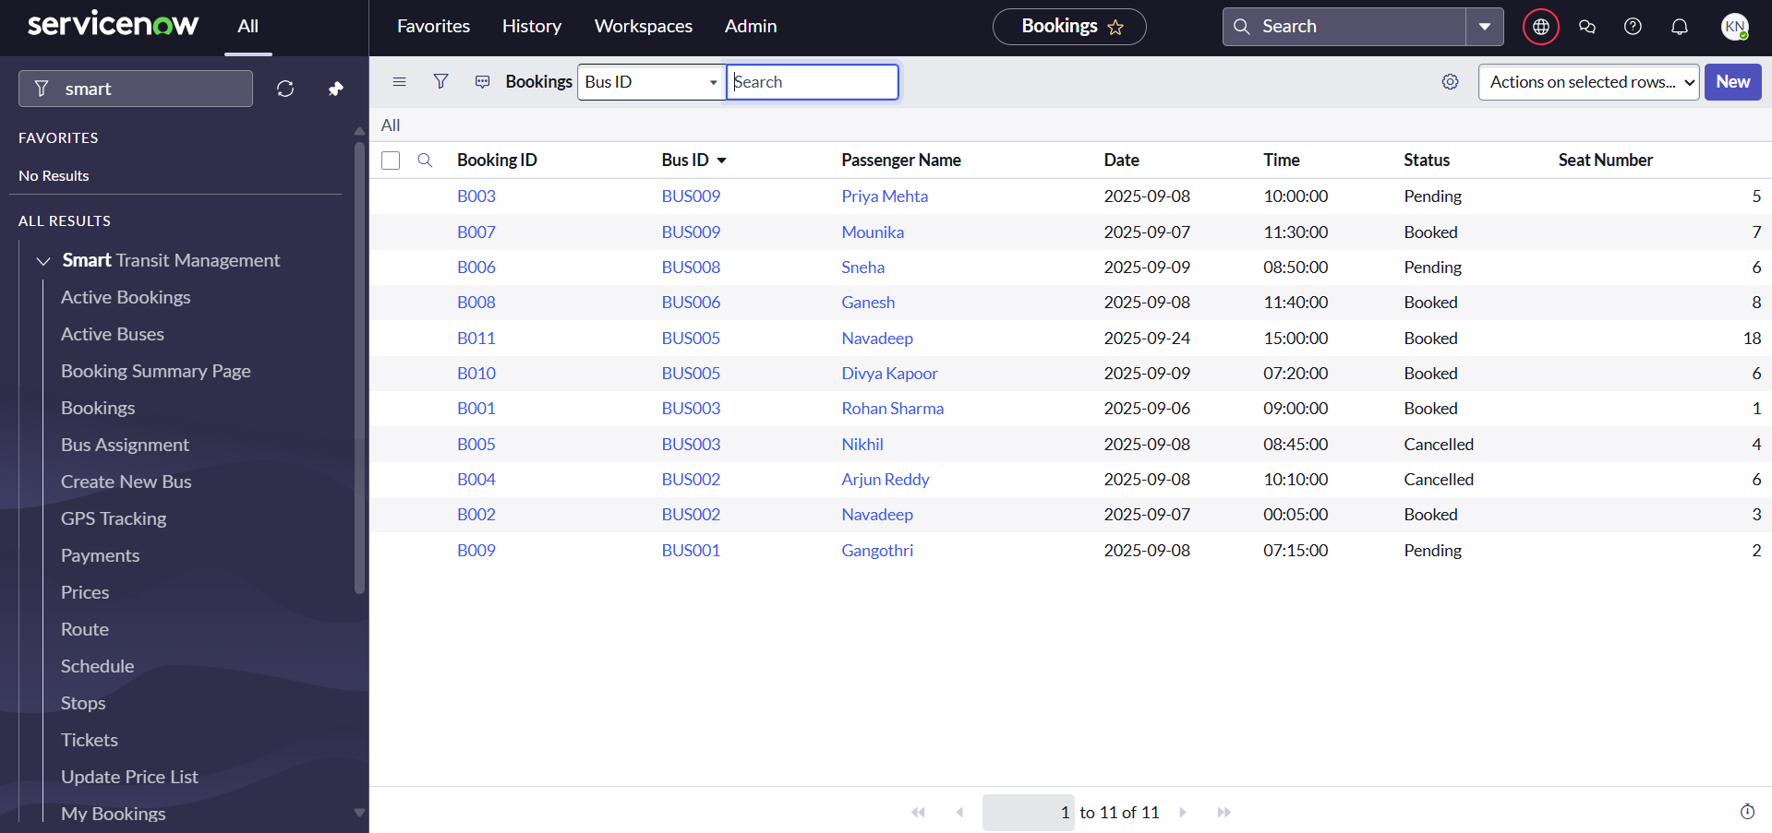

**Table 2: Active Buses**

**This table displays the buses that are available for the service to passengers**

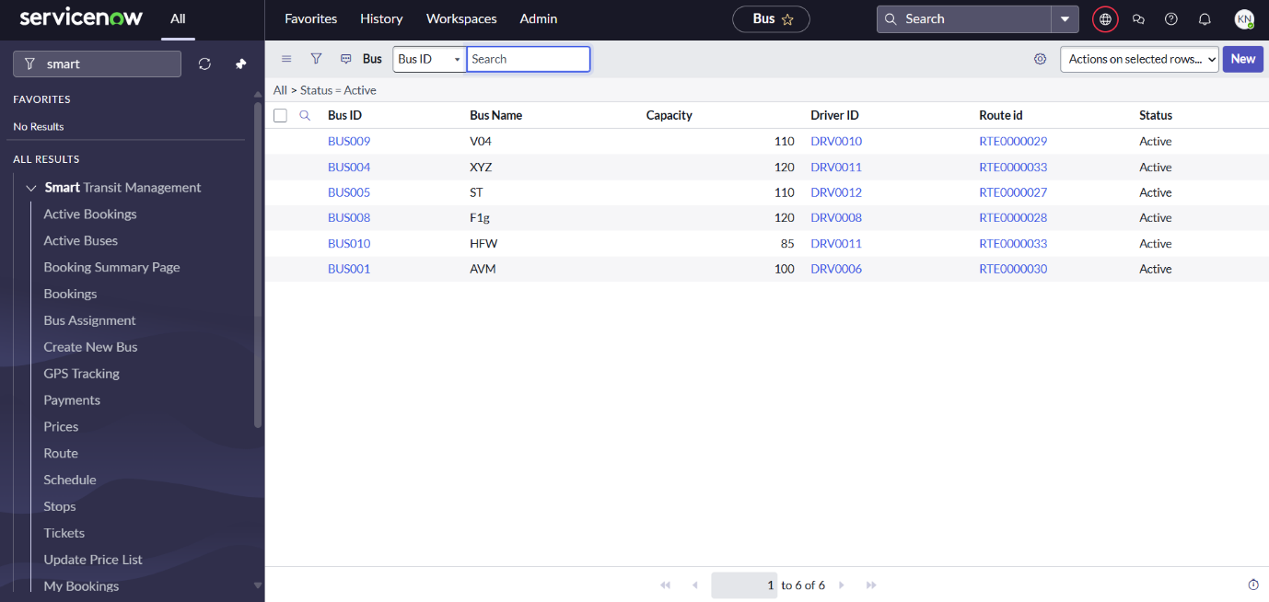

**Table 3: GPS Tracking**

**This table displays the GPS tracking of the buses with their BusID referenced to the Bus table**

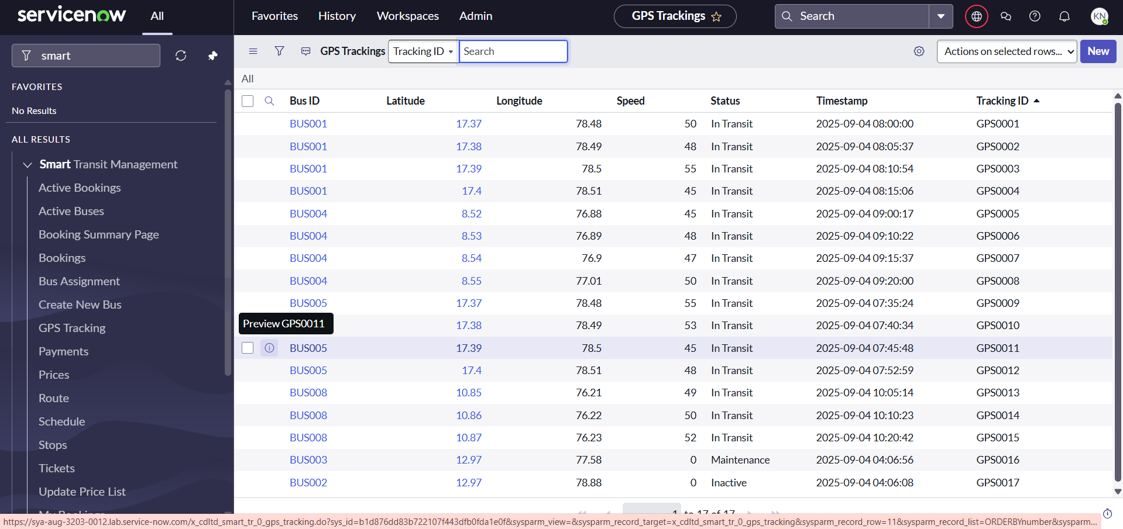

**Table 4: Payments**

**This Payments table deals with the payments status and mode of the payment made by the passenger**

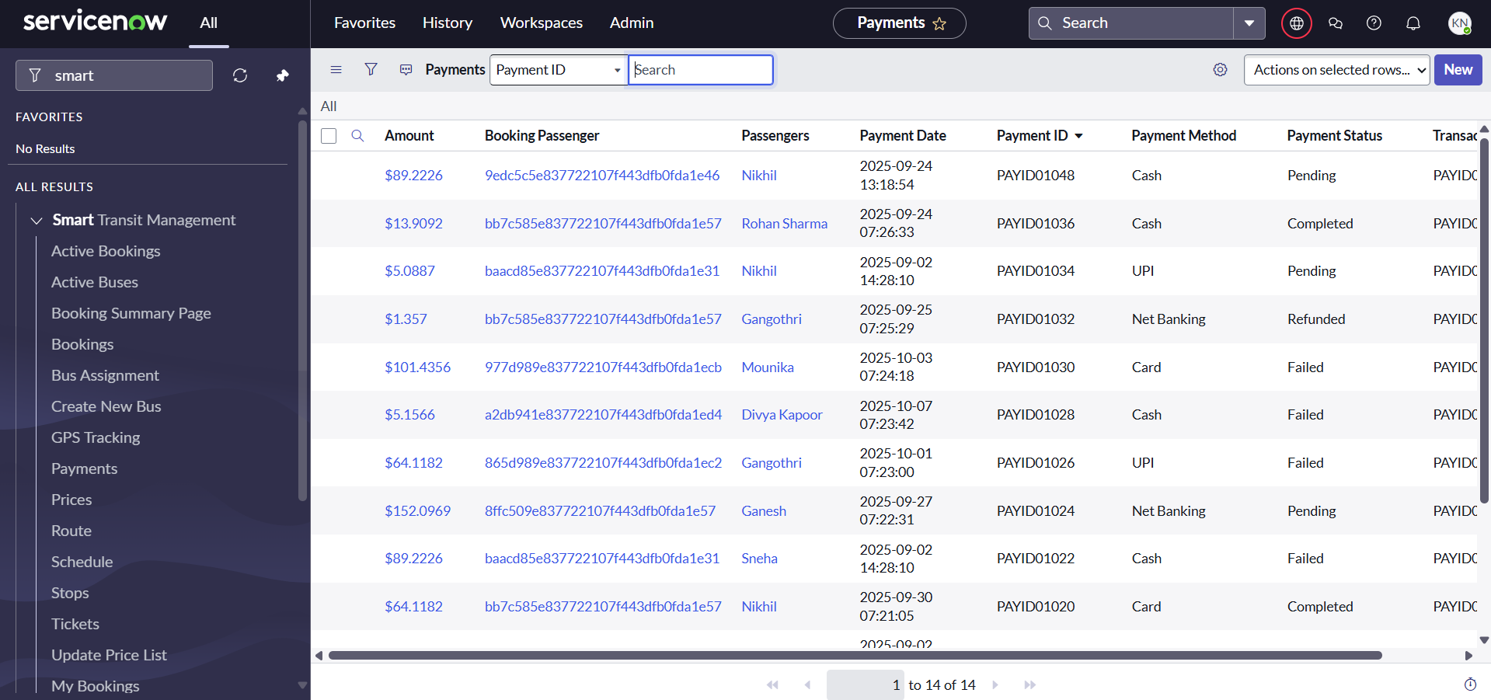

**Table 5: Prices**

**This table shows the bus charges from one point to another point**

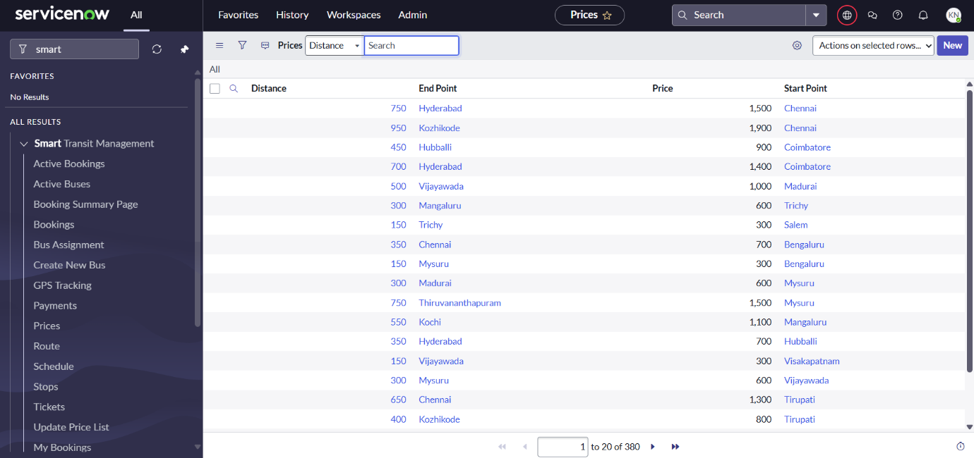

**Table 6: Route**

**This table displays in detail stops from start point to end point.**

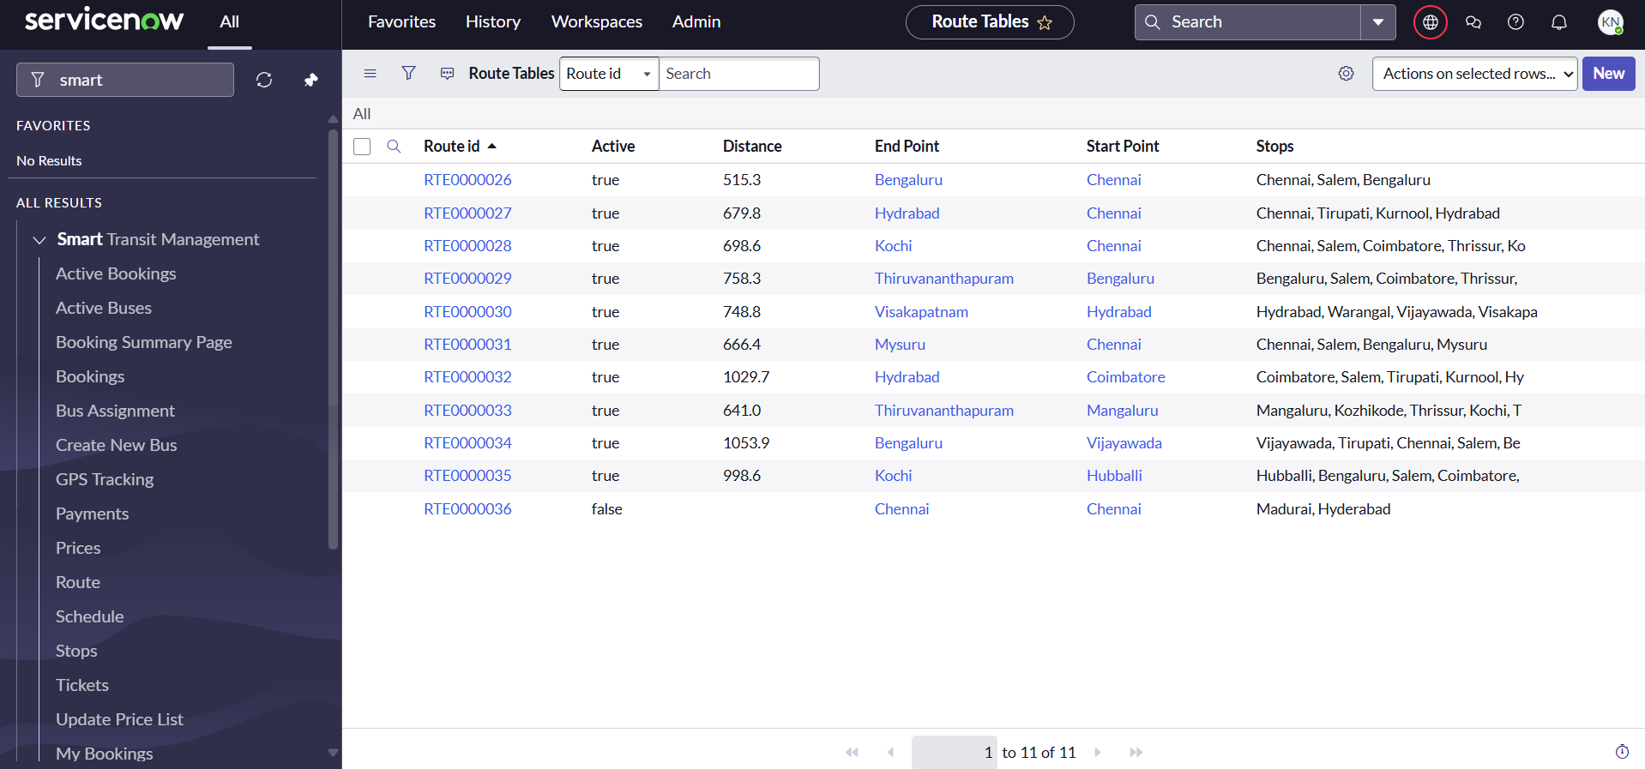

**Table 7: Schedule**

**This table deals with scheduling the bus with arrival time to the start point and depart time at the end point**

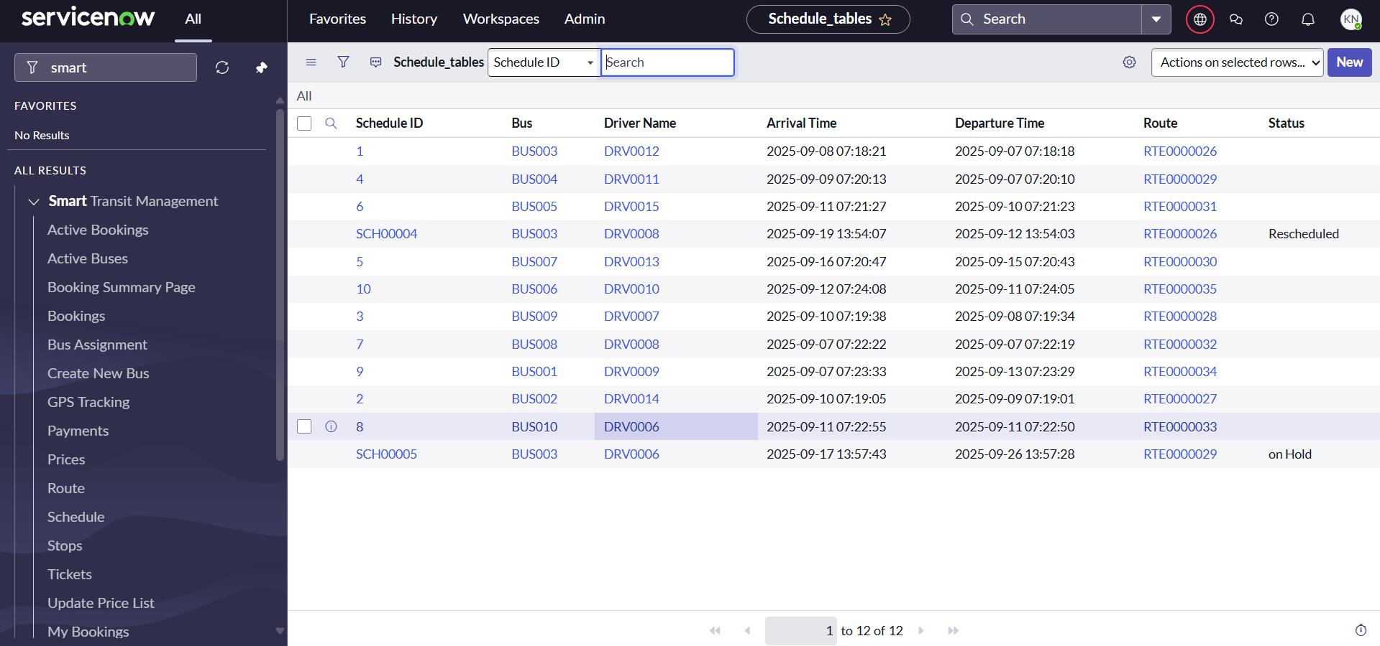

**Table 8: Ticket**

**This table displays the TicketID and activeness of the ticked as Booked, Completed or Cancelled**

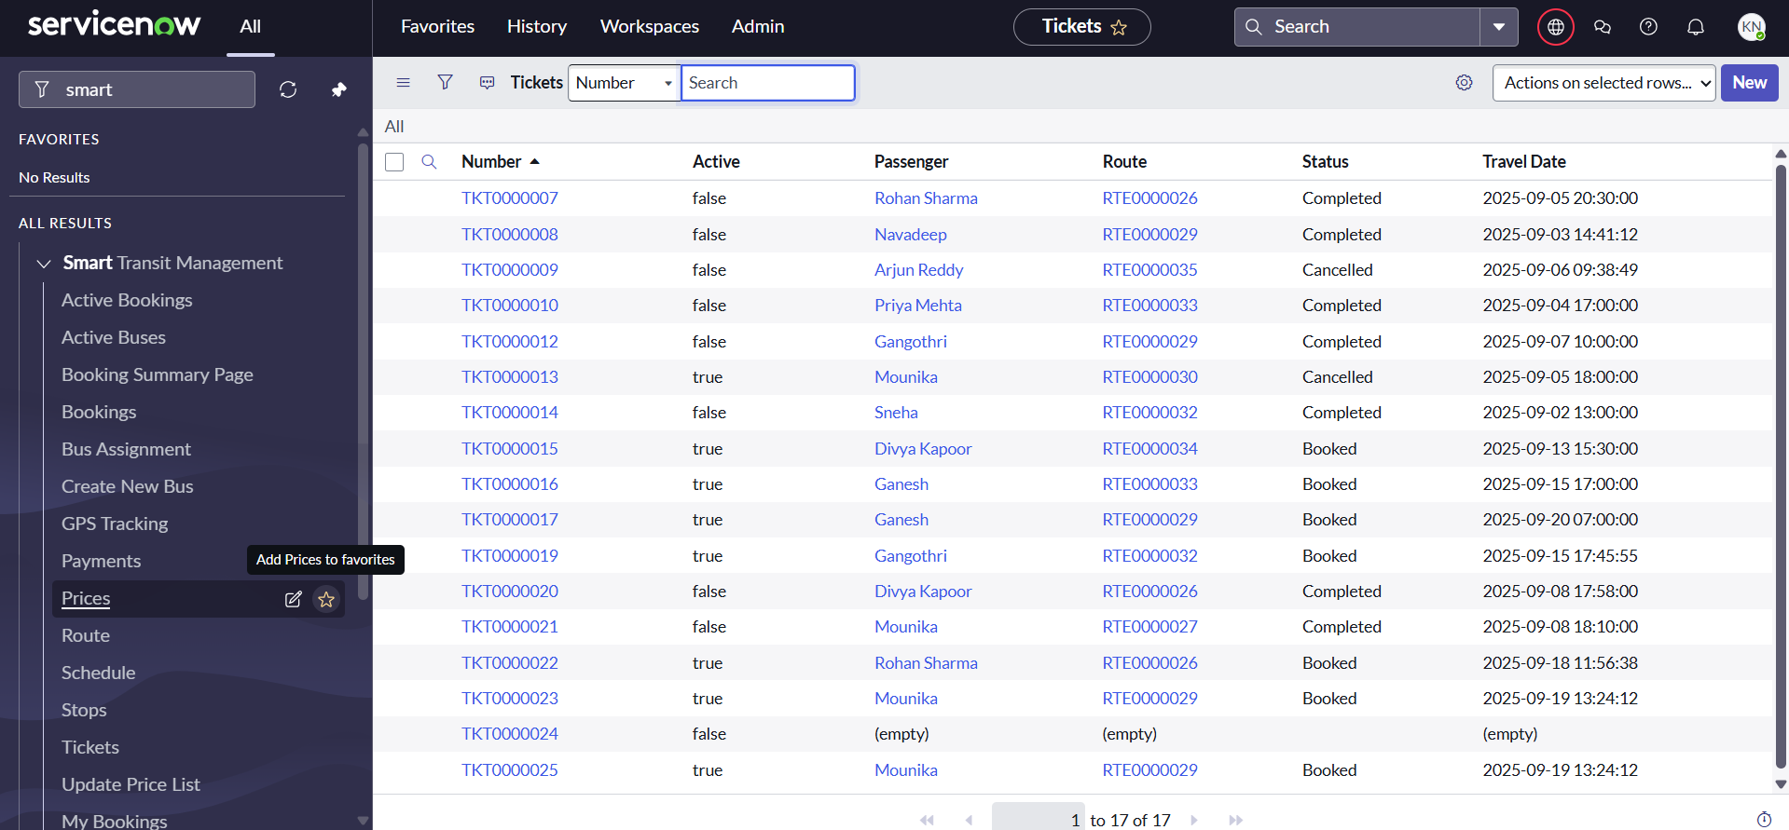

**Table 9: Feedback**

**This table displays the feedback given by each passenger after completion of their journey in their scheduled bus.**

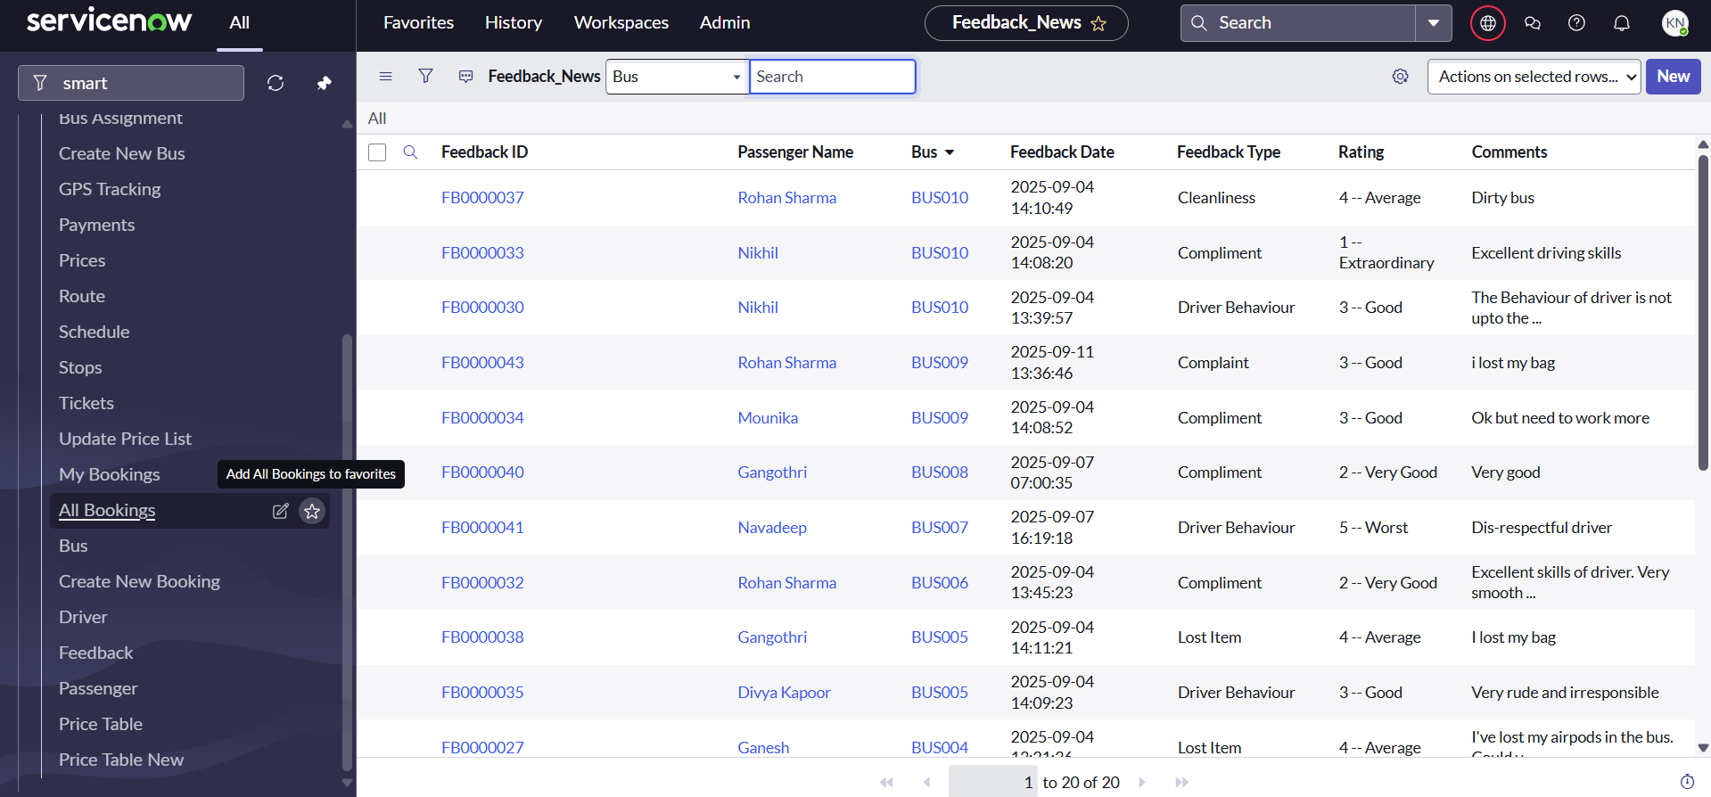

**Table 10: Passenger**

**This table displays the details of the passenger**

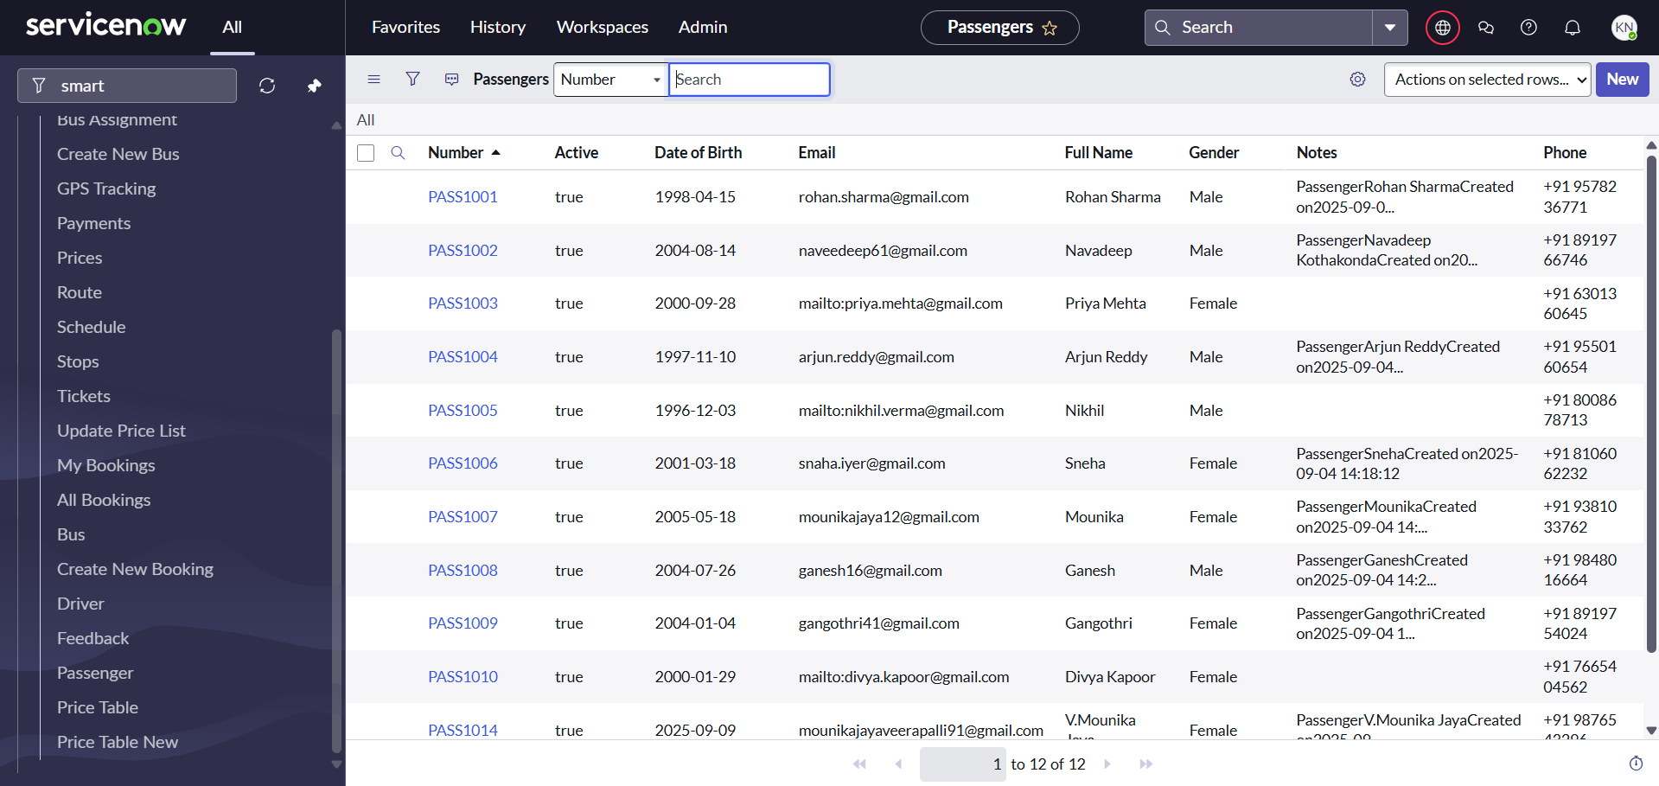

**Table 11: Drivers**

**This table deals with the contact details of the bus driver**

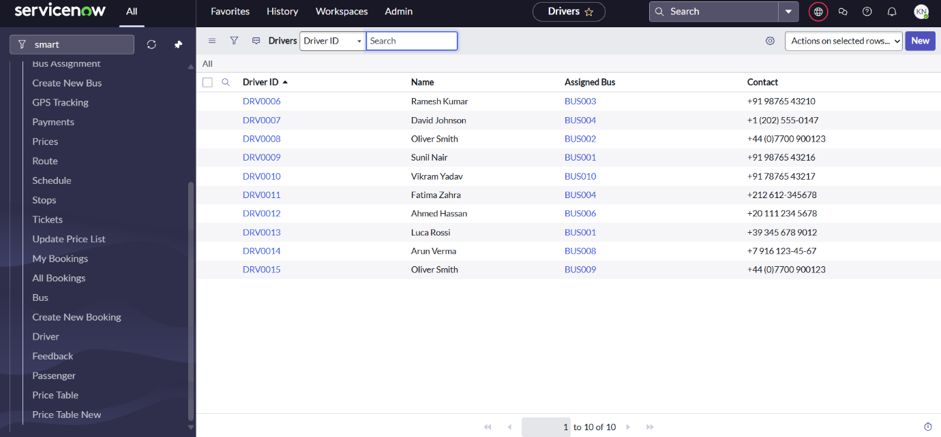

**Table 12: Bookings**

**This table deals with booking of bus for a particular bus**



**Mile stone 4: Creating Forms**

1.Select the Create icon [+] and then select File**.**



2.Specify the Application the file will belong to: *Smart Transit Management System.*

3.Select Data on the left-side panel.

4.Scroll down and select Forms as the file type.

5.Select Continue.

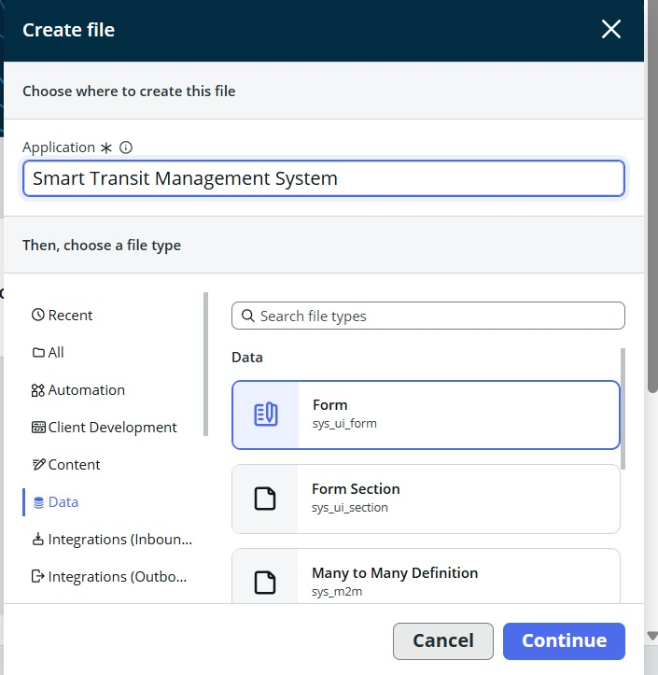

**Select table name:** Route Table

6.Select Open

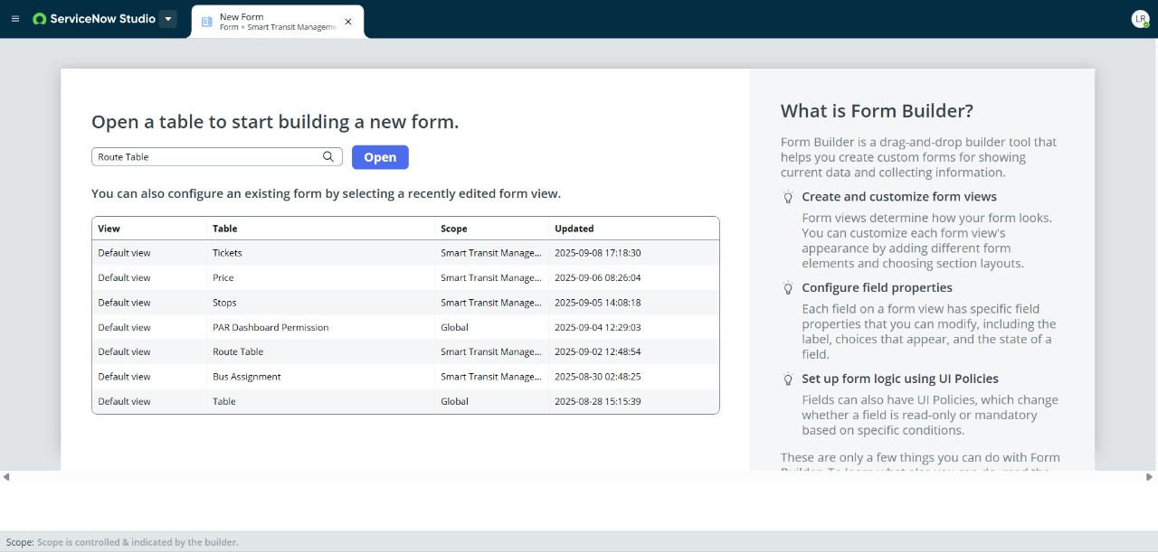

7.Add the field required fields in the form.  
8.Select save.

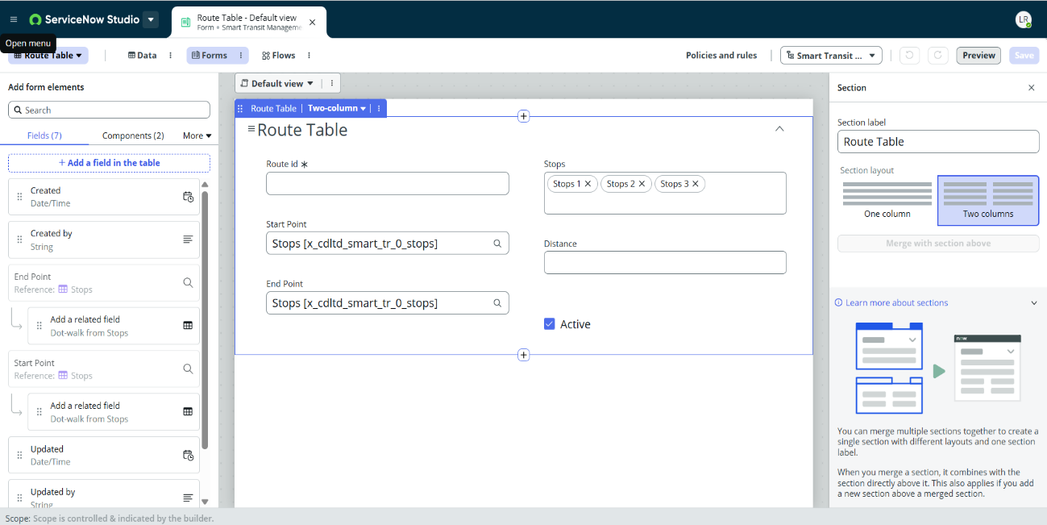

**Similarly, create form for other tables:**

1.Bookings[x_cdlt_d_smart_tr_0_bookings]

2.Bus[x_cdlt_d_smart_tr_0_bus]

3.Driver[x_cdlt_d_smart_tr_0_driver]

4.Feedback_new[x_cdlt_d_smart_tr_0_feedback_new]

5.GPS Tracking[x_cdlt_d_smart_tr_0_gps_tracking]

6.Passenger[x_cdlt_d_smart_tr_0_passenger]

7.Payment[x_cdlt_d_smart_tr_0_payment]

8.Price[x_cdlt_d_smart_tr_0_price]

**Mile stone 5: Creating Lists**

1.Select the Create icon [+] and then select File.



2.Specify the Application the file will belong to: *Smart Transit Management System.*

3.Select Data on the left-side panel.

4.Scroll down and select List as the file type.

5.Select Continue.

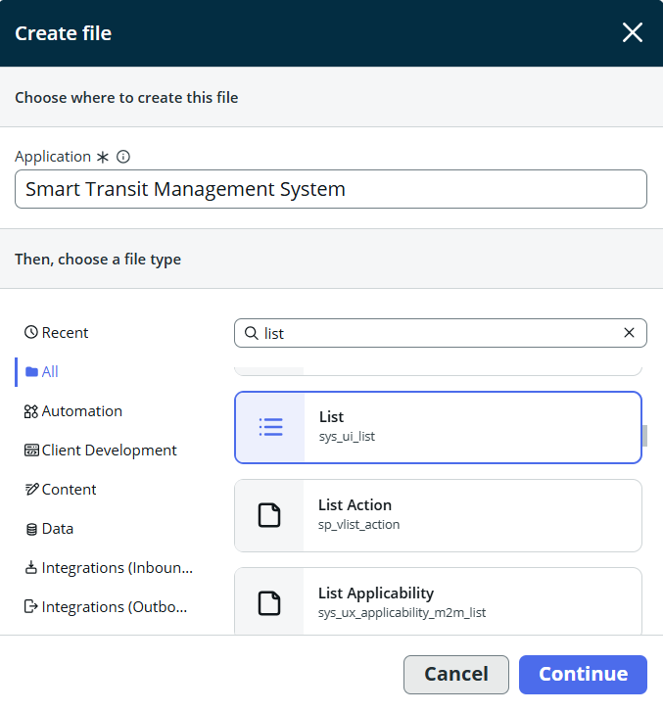

**Table:** Route Table[x_cdlt_d_smart_tr_0_route_table]

**Application:** Smart Transit Management System**.**

6.Select Submit**.**

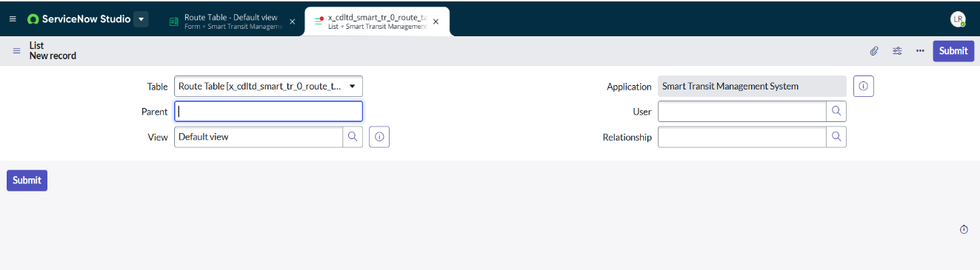

**Similarly, create list for other tables:**

1. Bookings[x_cdlt_d_smart_tr_0_bookings]
2. Bus[x_cdlt_d_smart_tr_0_bus]
3. Driver[x_cdlt_d_smart_tr_0_driver]
4. Feedback_new[x_cdlt_d_smart_tr_0_feedback_new]
5. GPS Tracking[x_cdlt_d_smart_tr_0_gps_tracking]
6. Passenger[x_cdlt_d_smart_tr_0_passenger]
7. Payment[x_cdlt_d_smart_tr_0_payment]
8. Price[x_cdlt_d_smart_tr_0_price]
9. Schedule_table[x_cdlt_d_smart_tr_0_schedule_table]
10. Stops[x_cdlt_d_smart_tr_0_stops]
11. Tickets[x_cdlt_d_smart_tr_0_tickets]

**Mile stone 6: Creating Flows**

1.Select the Create icon [+] and then select File.



2.Specify the Application the file will belong to: *Smart Transit Management System.*

3.Select Automation on the left-side panel.

4.Scroll down and select Flow(sys_hub_flow) as the file type.

5.Select Continue.

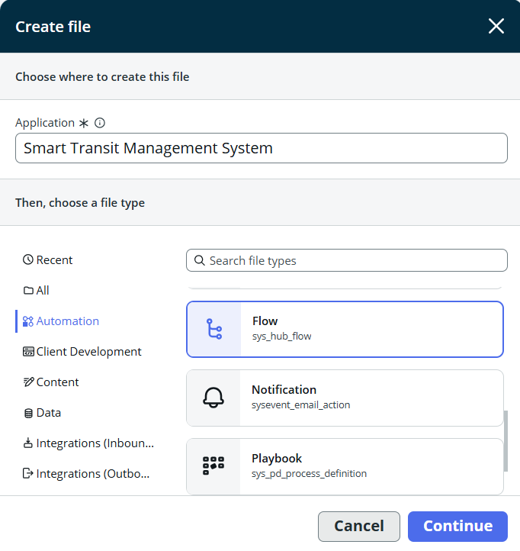

**Activity 1:**

**Flow Name:** Auto Complete Ticket Status.

**Application:** Smart Transit Management System.

**Description:** This flow runs daily to check booked tickets with past travel dates and automatically updates their status, ensuring ticket records stay accurate.

Select **Build Flow.**

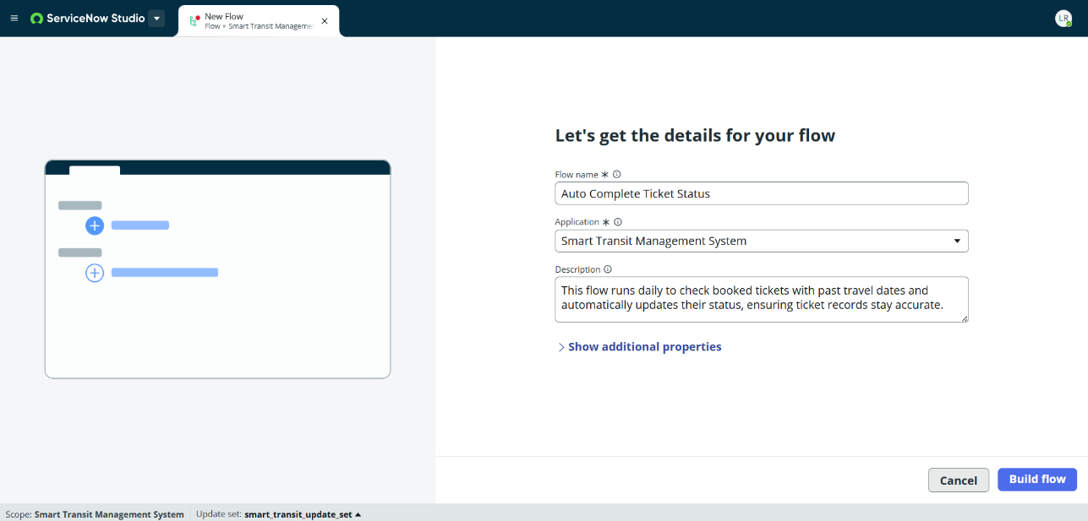

**Step 1: Add Trigger**

* Click on Add Trigger.
* Select Daily at 00:00:00.

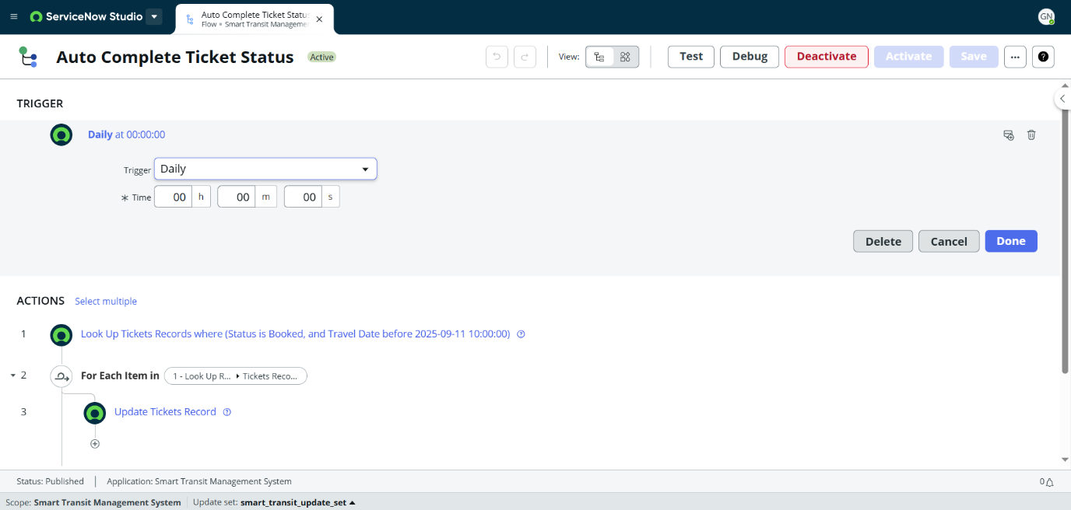

**Step 2: Add Action – Look Up Records**

* Click Add Action → select Look Up Records.
* Configure conditions: Status = Booked and Travel Date < Current Date.

**Step 3: Add Action – For Each**

* Add a For Each action.
* Choose the collection from the previous Look Up Records step.

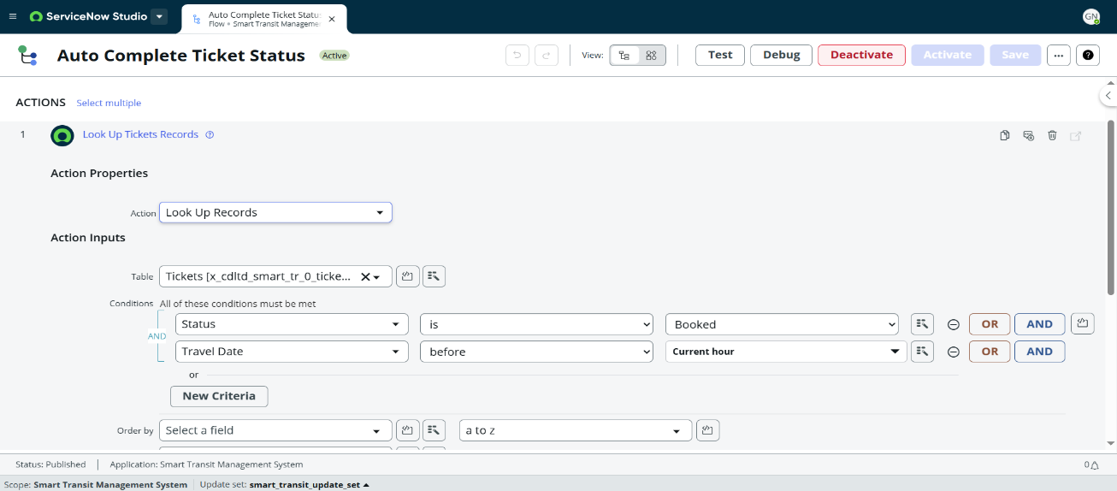

**Step 4: Add Action – Update Record**

* Inside the loop, add Update Record.
* Update Ticket Status = Completed (or your required value).

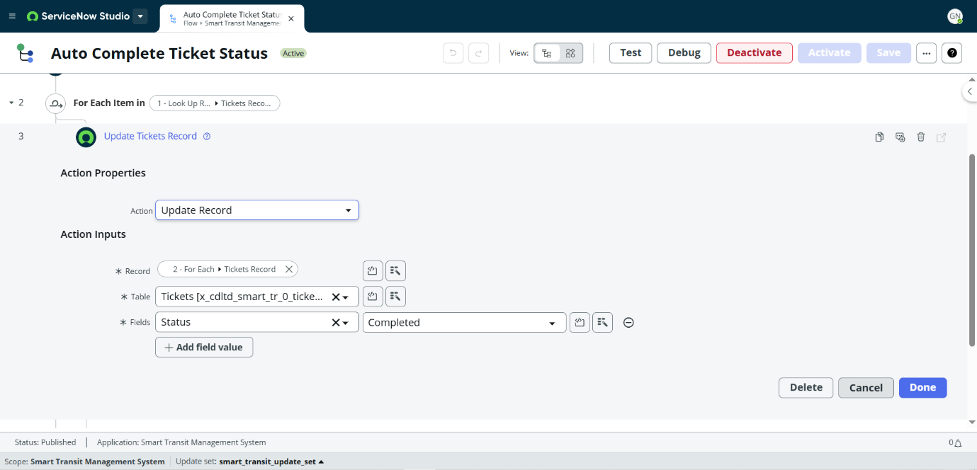

**Step 5: Save and Activate Flow**

* Click Save → then Activate.

**Activity 2: Auto fill Ticket Amount**

**Flow Name:** Auto fill Ticket Amount  
**Application:** Smart Transit Management System  
**Description:** This flow automatically calculates and updates the ticket amount whenever a new ticket is created or updated, based on the selected Start Point and End Point.

**Step 1: Add Trigger**

* Click on Add Trigger.
* Select Record Created or Updated.
* Condition: *Tickets Created or Updated where (Start Point is not empty, and End Point is not empty)*.

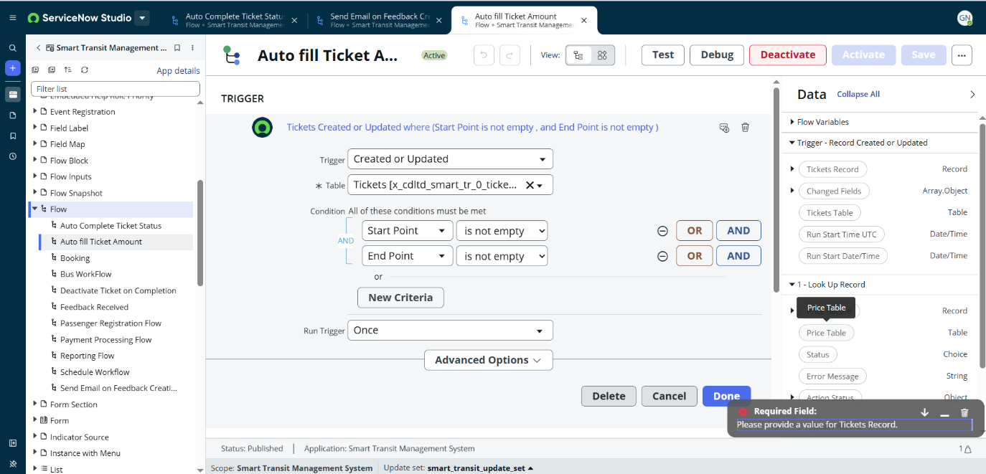

**Step 2: Add Action – Look Up Record**

* Click Add Action → select Look Up Records.
* Configure: *Look Up Price Record where (Start Point = Ticket Start Point, End Point = Ticket End Point)*.

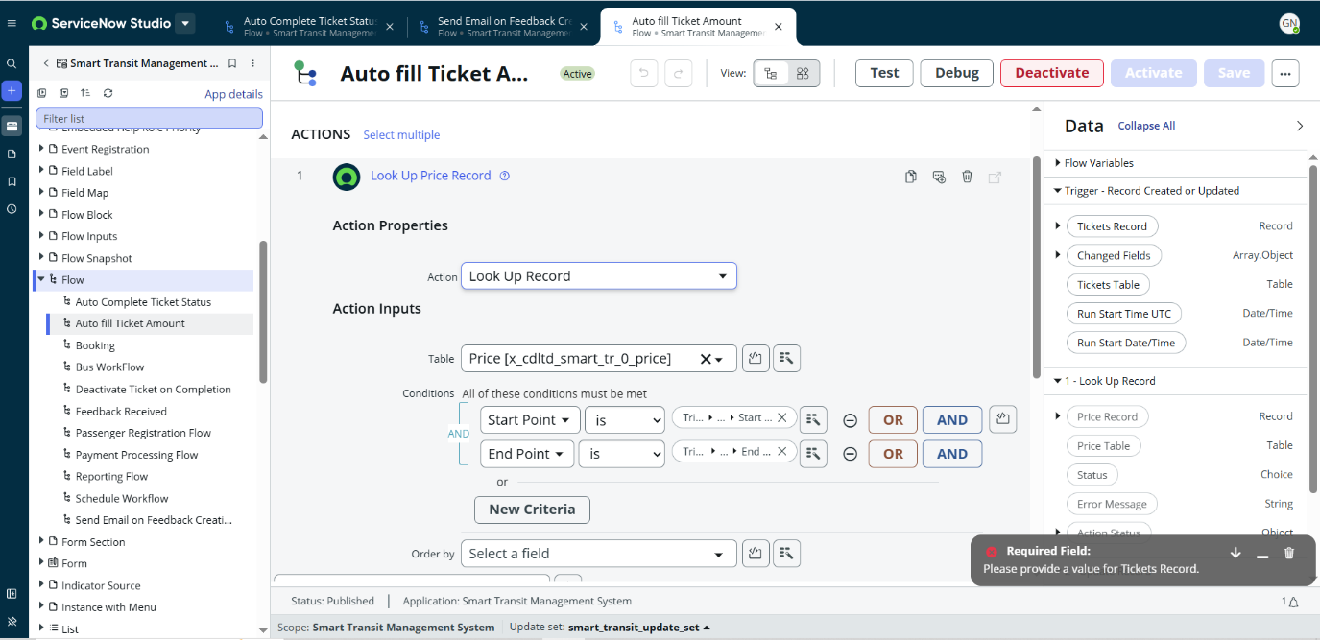

**Step 3: Add Action – Update Record**

* Add an Update Record action.
* Configure it to update the Ticket record with the calculated price amount.

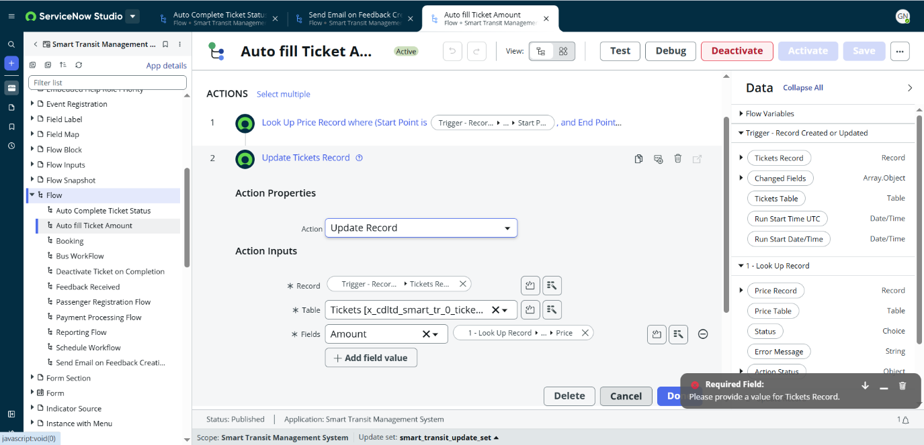

**Step 4: Save and Activate Flow**

* Click Save → then Activate to enable the flow.

**Activity 3: Deactivate Ticket on Completion**

**Flow Name:** Deactivate Ticket on Completion **Application:** Smart Transit Management System  
 **Description:** This flow automatically deactivates a ticket once its status is updated to *Completed*.

**Step 1: Add Trigger**

* Click on Add Trigger.
* Select Record Updated.
* Condition: Tickets Updated where (Status = Completed).

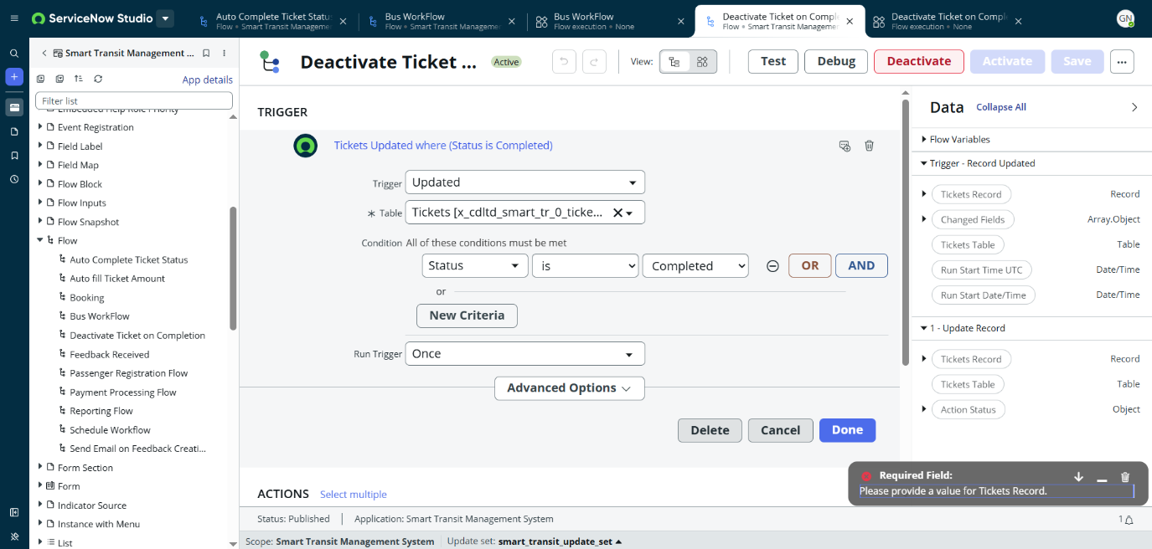

**Step 2: Add Action – Update Record**

* Add an Update Record action.
* Configure it to update the Ticket record so that it becomes deactivated once the status is completed.

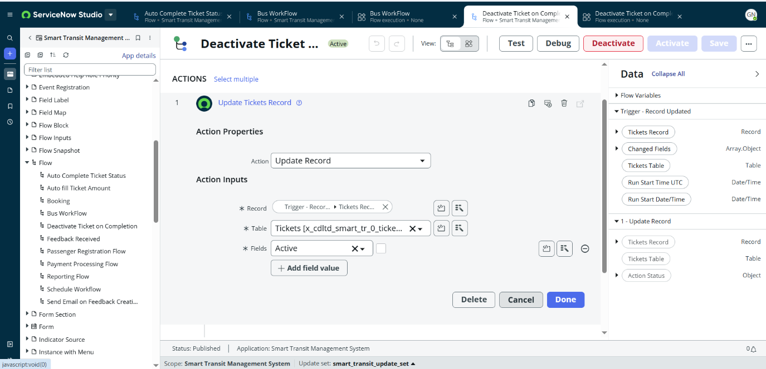

**Step 3: Save and Activate Flow**

* Click Save → then Activate.

**Activity 4: Passenger Registration Flow**

**Flow Name:** Passenger Registration Flow  
**Application:** Smart Transit Management System  
**Description:** This flow manages passenger registration. When a new passenger is created, it updates the record, sends a confirmation email, and ensures data consistency.

**Step 1: Add Trigger**

* Click on Add Trigger.
* Select Record Created.
* Condition: *Passenger Created*.

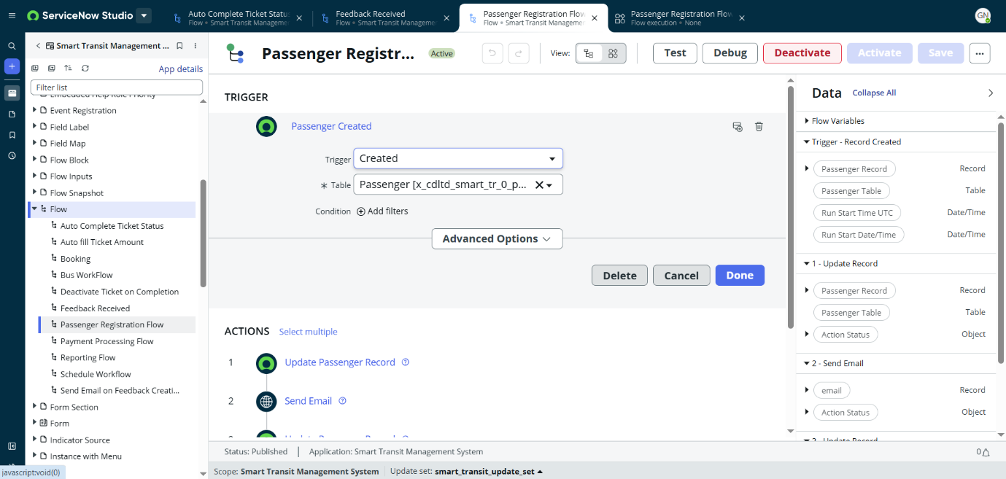

**Step 2: Add Action – Update Passenger Record**

* Add an Update Record action.
* Configure it to update the passenger details after registration.

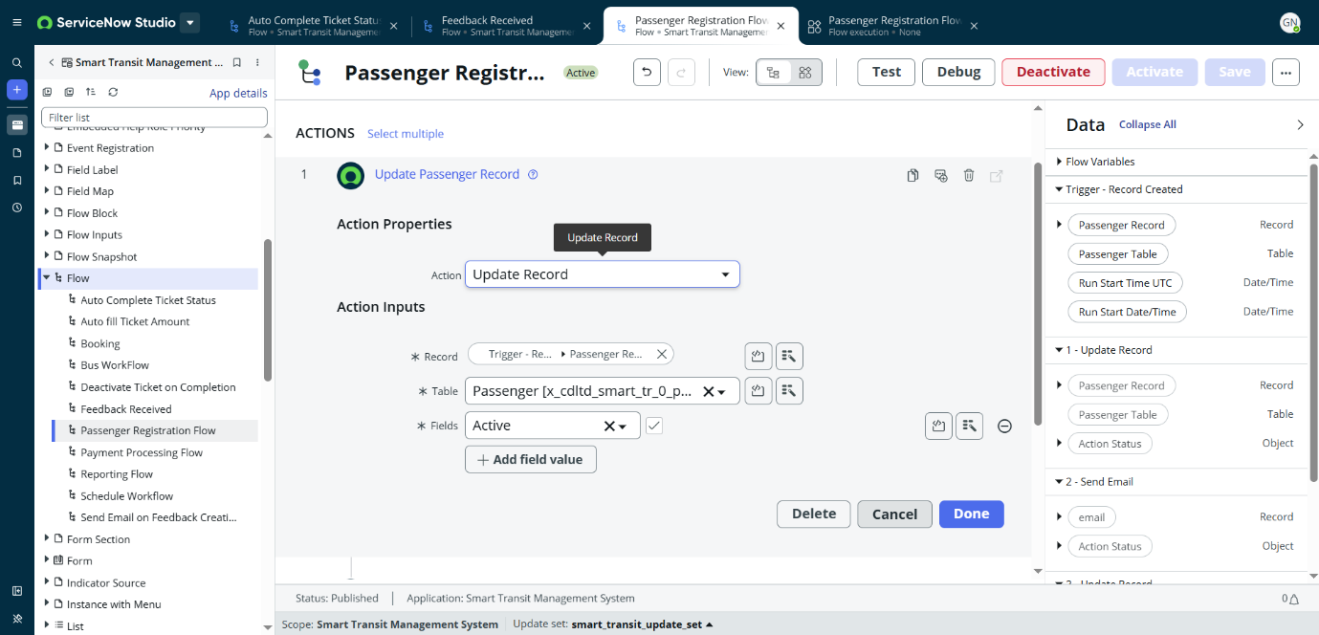

**Step 3: Add Action – Send Email**

* Add a Send Email action.
* Configure it to send a confirmation email to the registered passenger.

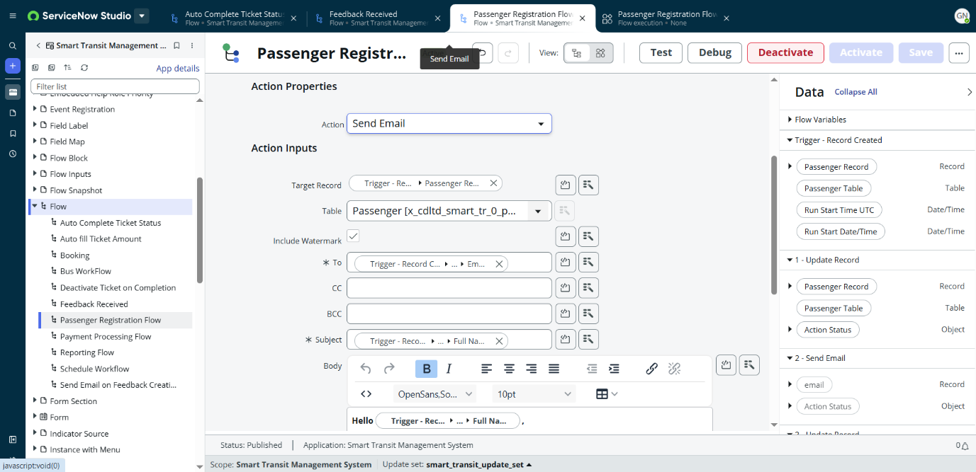

**Step 4: Add Action – Update Passenger Record (Final)**

* Add another Update Record action.
* Configure it to finalize or adjust the passenger’s status after email confirmation.

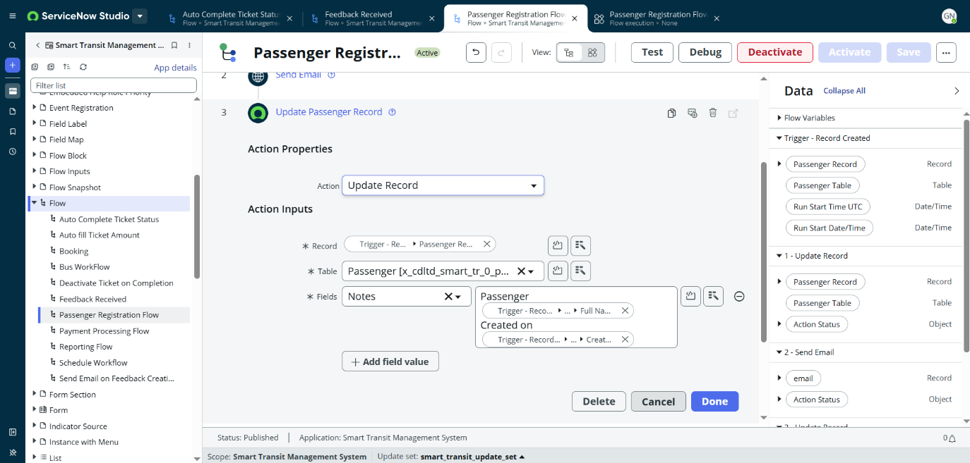

**Step 5: Save and Activate Flow**

* Click Save → then Activate.

**Activity 5: Reporting Flow**

**Flow Name:** Reporting Flow  
**Application:** Smart Transit Management System  
**Description:** This flow generates automated reports daily by retrieving active routes and bus assignments, then sends them via email to administrators.

**Step 1: Add Trigger**

* Click on Add Trigger.
* Select Run Daily.
* Condition: *Daily at 06:00:00*.

**Step 2: Add Action – Look Up Route Table Records**

* Add a Look Up Records action.
* Configure it to look up all Route Table Records.

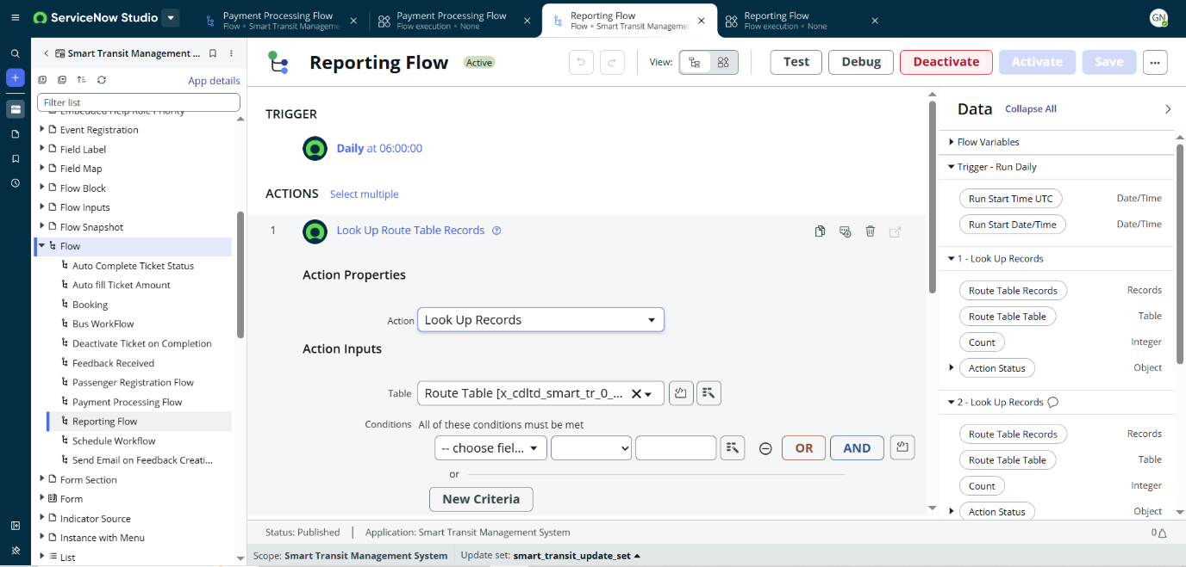

**Step 3: Add Action – Look Up Active Routes**

* Add another Look Up Records action.
* Configure it to look up all Route Table Records where Active = true.

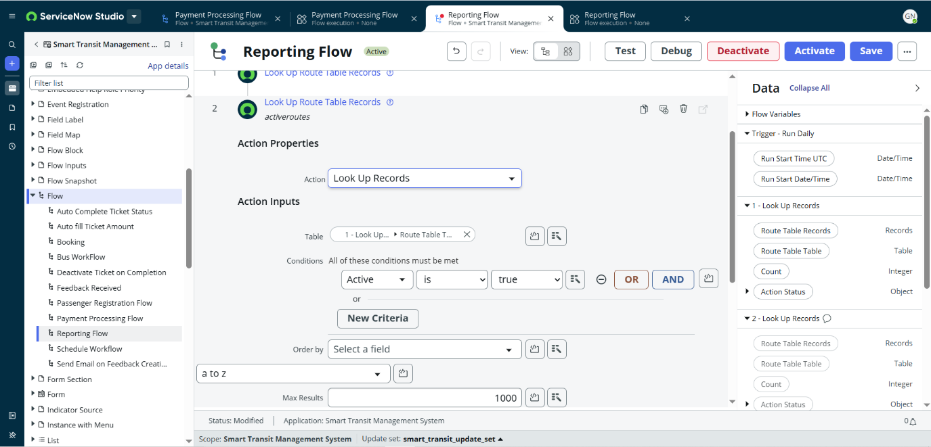

**Step 4: Add Action – Send Email**

* Add a Send Email action.
* Configure it to send the daily report to the relevant recipients.

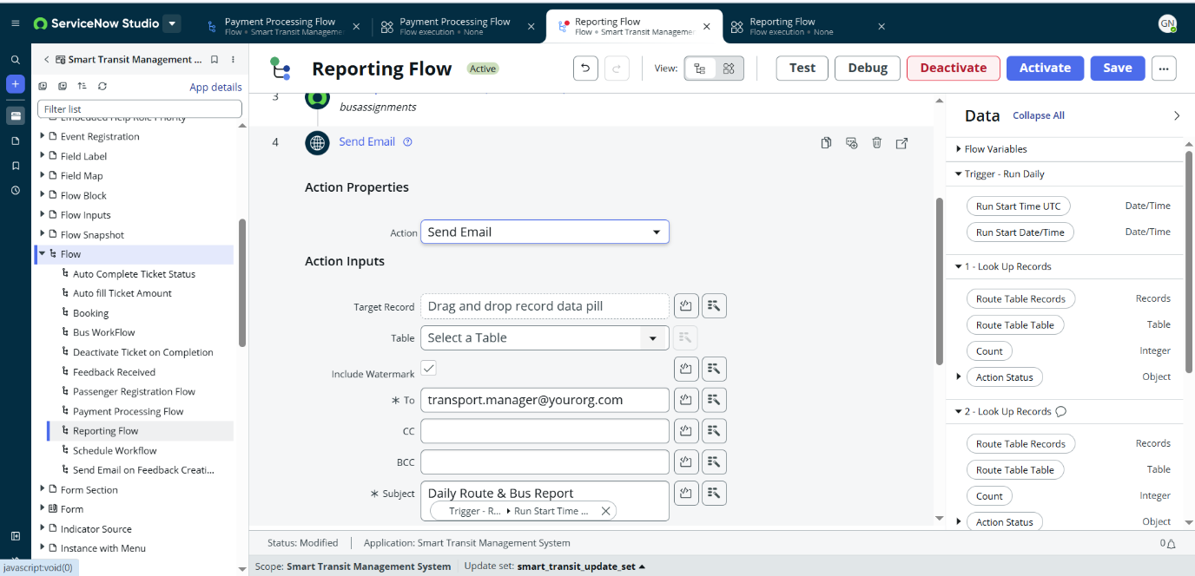

**Step 6: Save and Activate Flow**

* Click Save → then Activate.

**Activity 6: Send Email on Feedback Creation**

**Flow Name:** Send Email on Feedback Creation  
**Application:** Smart Transit Management System  
**Description:** This flow ensures that whenever feedback is created, an email notification is automatically sent to the admin or support team for quick action.

**Step 1: Add Trigger**

* Click on Add Trigger.
* Select Record Created.
* Condition: *Feedback Created*.

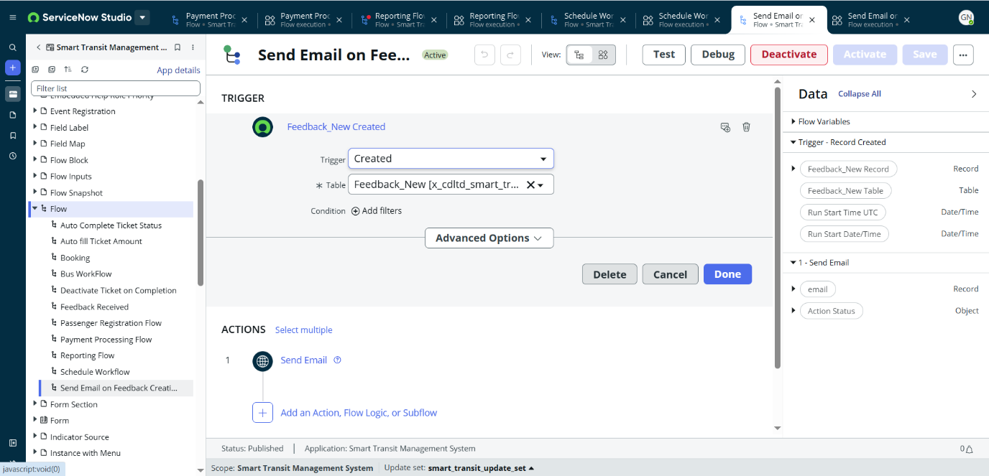

**Step 2: Add Action – Send Email**

* Add a Send Email action.
* Configure it to send an acknowledgment or notification email to the admin/support team.

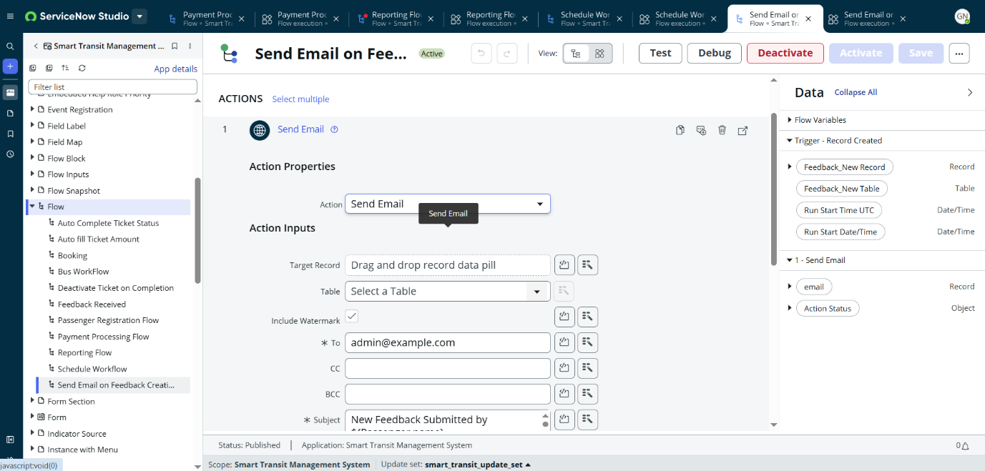

**Step 3: Save and Activate Flow**

* Click Save → then Activate.

**Activity 7: Payment Processing Flow**

**Flow Name:** Payment Processing Flow  
**Application:** Smart Transit Management System  
**Description:** This flow ensures that whenever a passenger makes a payment, the payment record is updated, and related actions such as sending a confirmation email or updating ticket status are performed automatically.

**Step 1: Add Trigger**

* Click on Add Trigger.
* Select Record Created or Updated.
* Condition: *Payment Record Created or Updated*.

**Step 2: Add Action – Update Payment Record**

* Add an Update Record action.
* Configure it to mark the payment as Processed or Completed once validated.

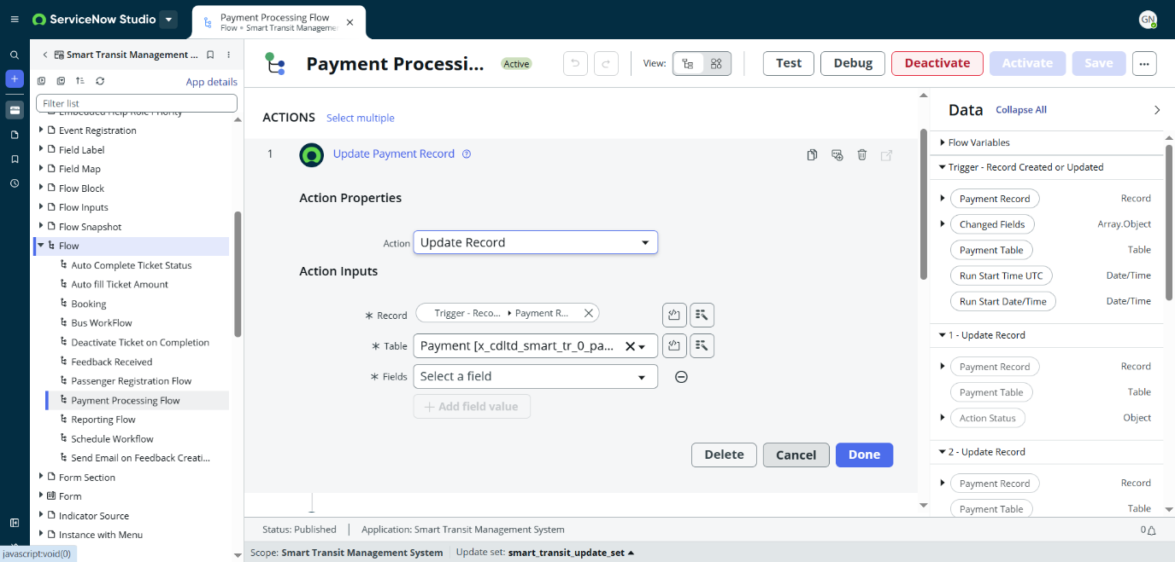

**Step 3: Add Action – Update Payment Record**

* Add another Update Record action.
* Configure it to update the Ticket Status (e.g., Paid, Confirmed) once the payment is successful.

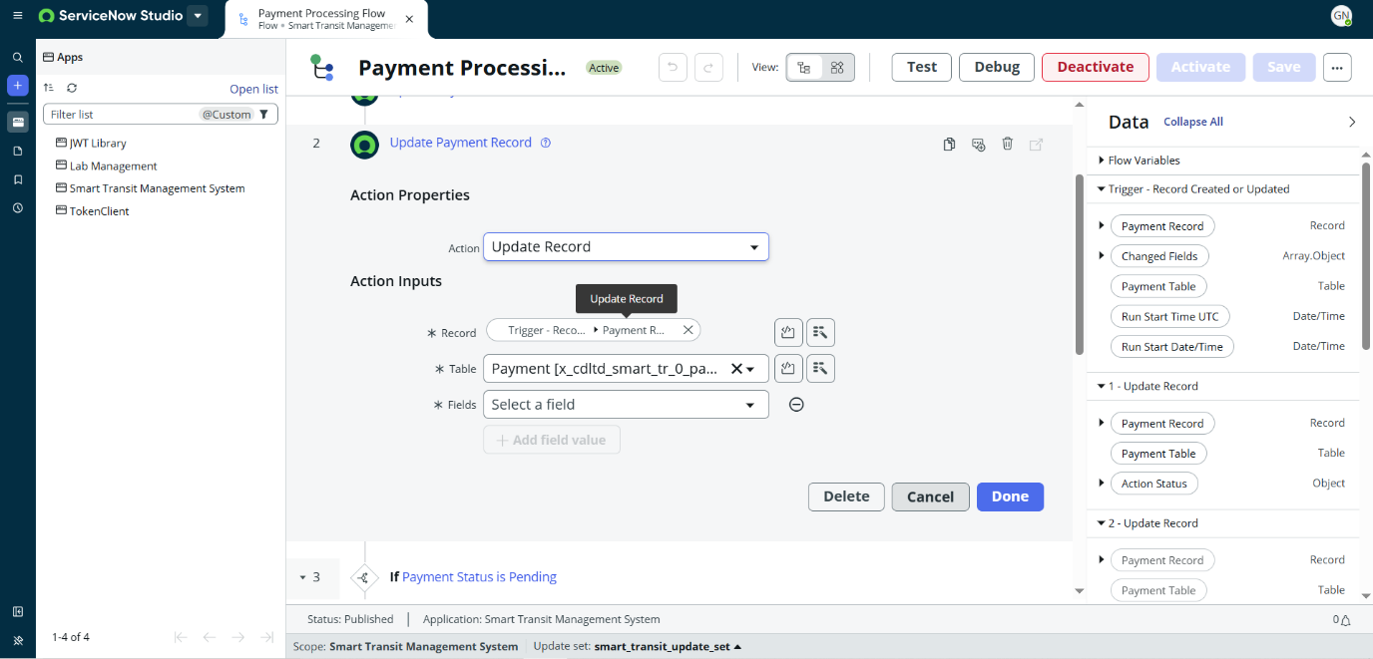

**Step 4: Add Action – Send Confirmation Email**

* Add a Send Email action.
* Configure it to send a Payment Confirmation Email to the passenger

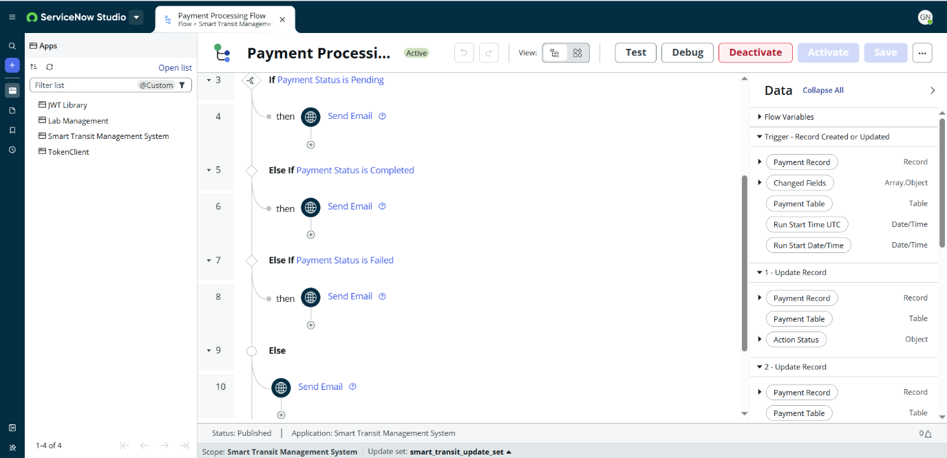

**Step 5: Save and Activate Flow**

* Click Save → then Activate.

**Activity 8: Booking Flow**

**Flow Name:** Booking Flow  
**Application:** Smart Transit Management System  
**Description:** This flow automates the booking process. When a passenger creates a new booking, it updates the booking record, assigns a seat, and sends a booking confirmation email.

**Step 1: Add Trigger**

* Click on Add Trigger.
* Select Record Created.
* Condition: *Booking Created*.

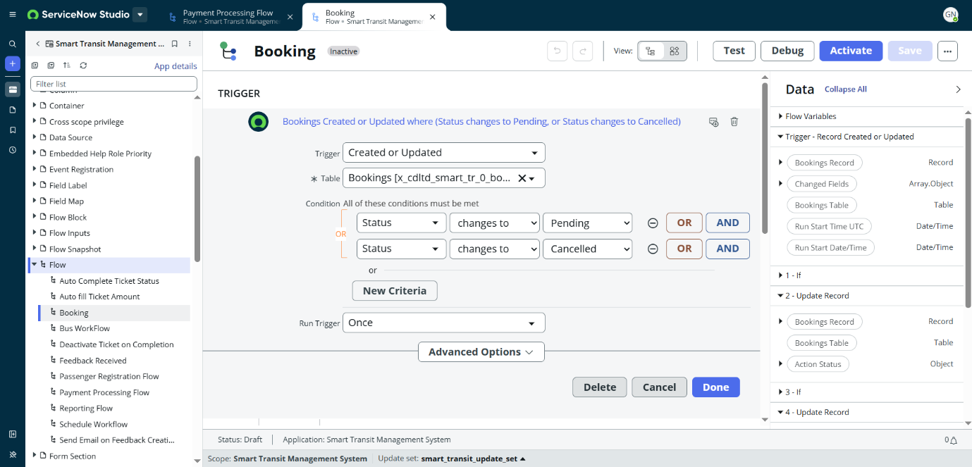

**Step 2: Add Action – If Status = Pending**

* Add a condition If Status == Pending.
* Then add Update Booking Record to set status or details for pending bookings.

**Step 3: Add Action – If Status = Booked**

* Add a condition If Status == Booked.
* Then add Update Booking Record to confirm the booking.

**Step 4: Add Action – If Status = Cancelled**

* Add a condition If Status == Cancelled.
* Then add Update Booking Record to mark the booking as cancelled

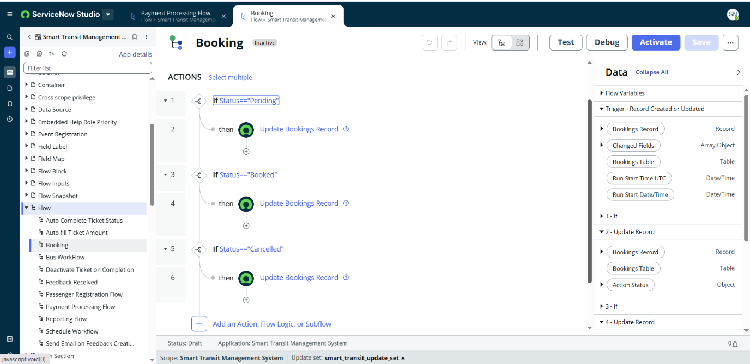

**Step 5: Save and Activate Flow**

* Click Save → then Activate.

**Activity 9: Bus Workflow**

**Flow Name:** Bus Workflow  
**Application:** Smart Transit Management System  
**Description:** This flow manages bus records. When a bus record is created or updated, the system updates related details such as status, schedule assignments, and sends notifications if needed.

**Step 1: Add Trigger**

* Click on Add Trigger.
* Select Record Created or Updated.
* Condition: *Bus Record Created or Updated*.

**Step 2: Add Condition – If Empty Bus Name**

* Add a condition: If Bus Name is Empty.
* Then perform further actions.

**Step 3: Add Action – Look Up Route Table Record**

* If the bus name is empty, add a Look Up Records action.
* Configure it to Look Up Route Table Record where Active = true and Route ID matches.

**Step 4: Add Else Condition – Log Action**

* Under the Else branch, add a Log Action to record the issue or error.

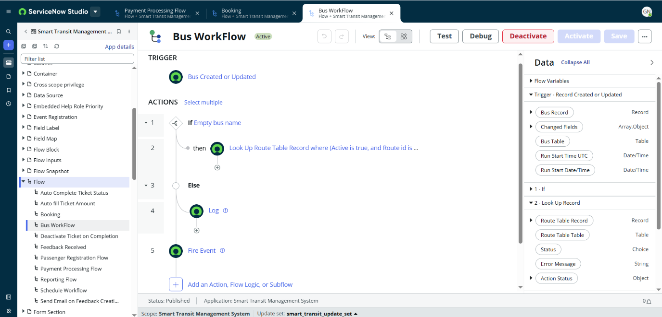

**Step 5: Add Action – Fire Event**

* Add a Fire Event action to trigger subsequent flows or notifications when needed.

**Step 6: Save and Activate Flow**

* Click Save → then Activate.

**Activity 10: Schedule Workflow**

**Flow Name:** Schedule Workflow  
**Application:** Smart Transit Management System  
**Description**: This flow manages bus schedules. When a new schedule is created or updated, it ensures driver assignment, bus assignment, and notifies the respective parties.

**Step 1: Add Trigger**

* Click on Add Trigger.
* Select Record Created or Updated.
* Condition: *Schedule Record Created or Updated*

**Step 2: Add Action – Send Email (Initial Notification)**

* Add a Send Email action.
* Configure it to notify admins/drivers when a new schedule is created or updated.

**Step 3: Add Condition – Validate Arrival and Departure Time**

* Add a condition: If Arrival Time ≤ Departure Time.
* This ensures schedules are logically valid.

**Step 4: Add Action – Send Email (Validation Notification)**

* If the condition is met, add another Send Email action.
* Configure it to notify about incorrect or overlapping schedule times.

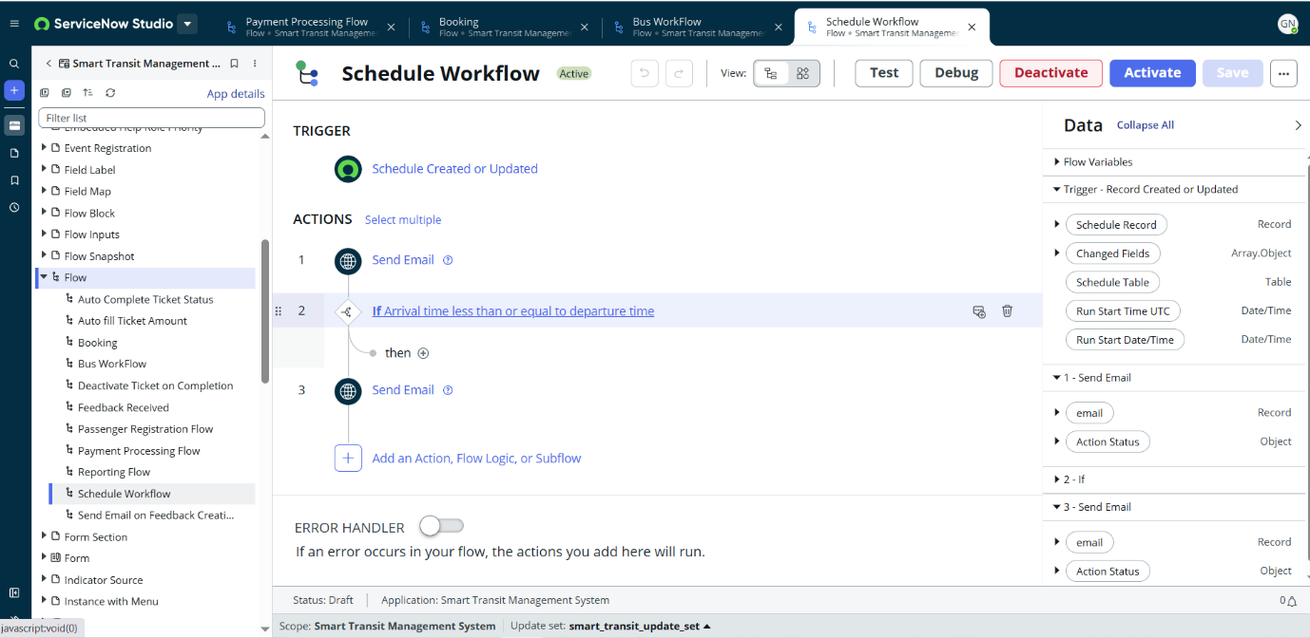

**Step 5: Save and Activate Flow**

* Click Save → then Activate.

**MileStone 7: Creating Reports**

**Activity – 1: Bus Utilization Report**

1.Navigate to All -> Reports and click on it.

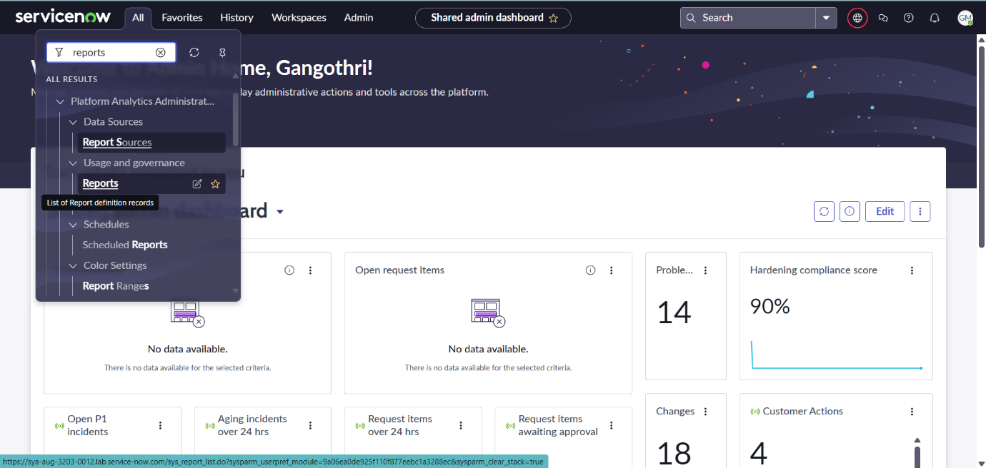

2.Click on new

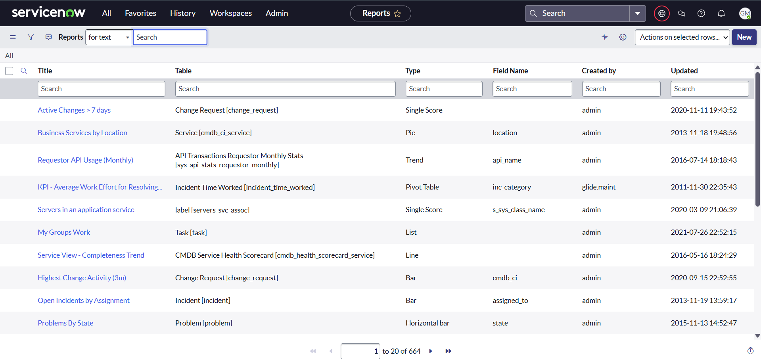

3.On Data pane, Enter following details.

* **Report Name:** Bus Utilization
* **Source Type:** Table
* **Table:** Tickets[c_cdltd_smart_tr_0_tickets

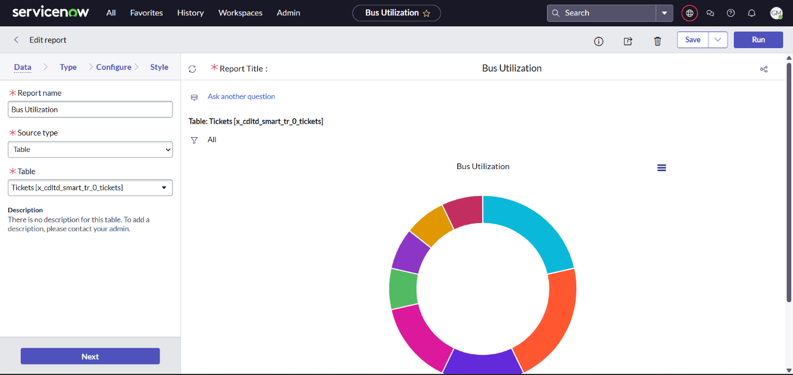

4.Click next and fill details as below in Type and configure pane.

* **Type:** Donut
* **Group by:** Route
* **Aggregation:** Count

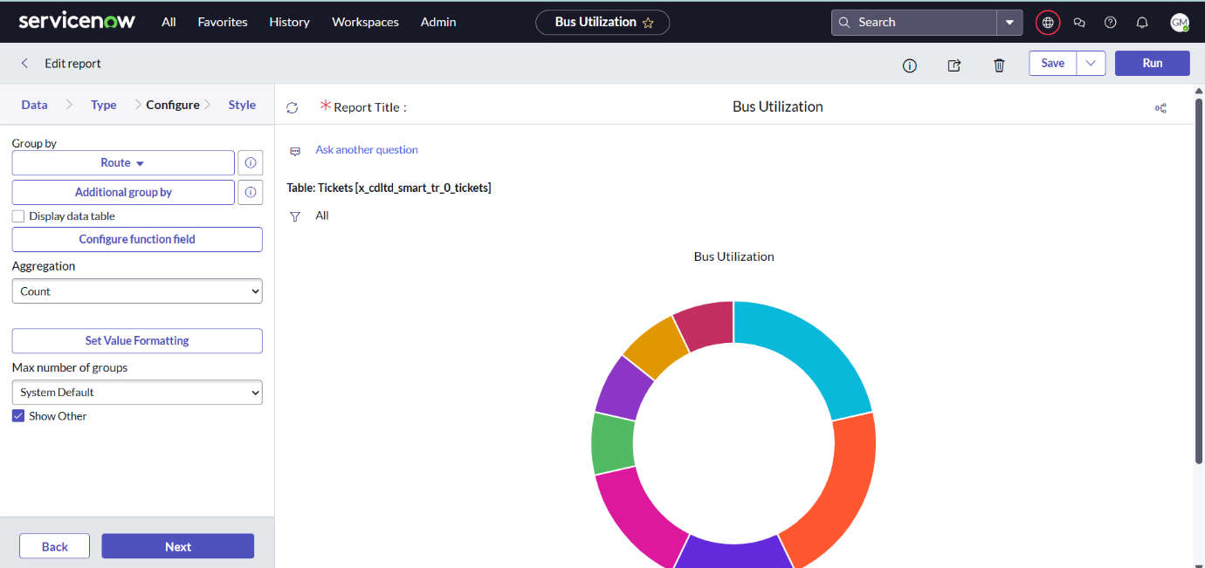

5.Save and Run it.



**Activity 2: Create Reports for remaining**

1.Repeat above steps for Daily Ticket Sales.

* **Name:** Daily Ticket Sales
* **Table:** Tickets
* **Type:** Bar

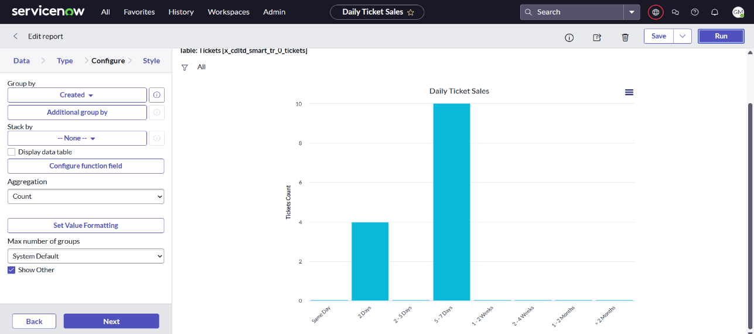

2.Feedback Report

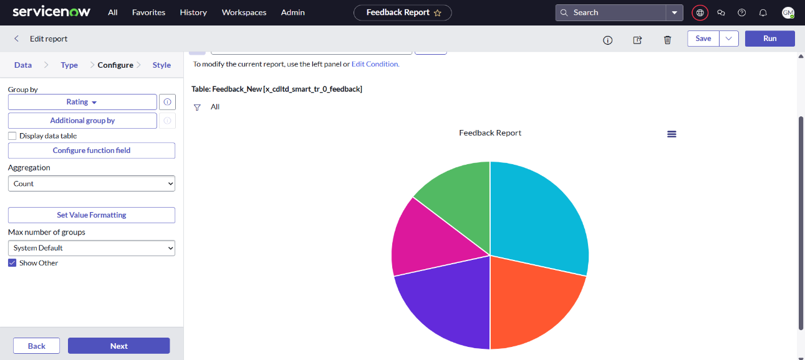

3.Payment Transactions

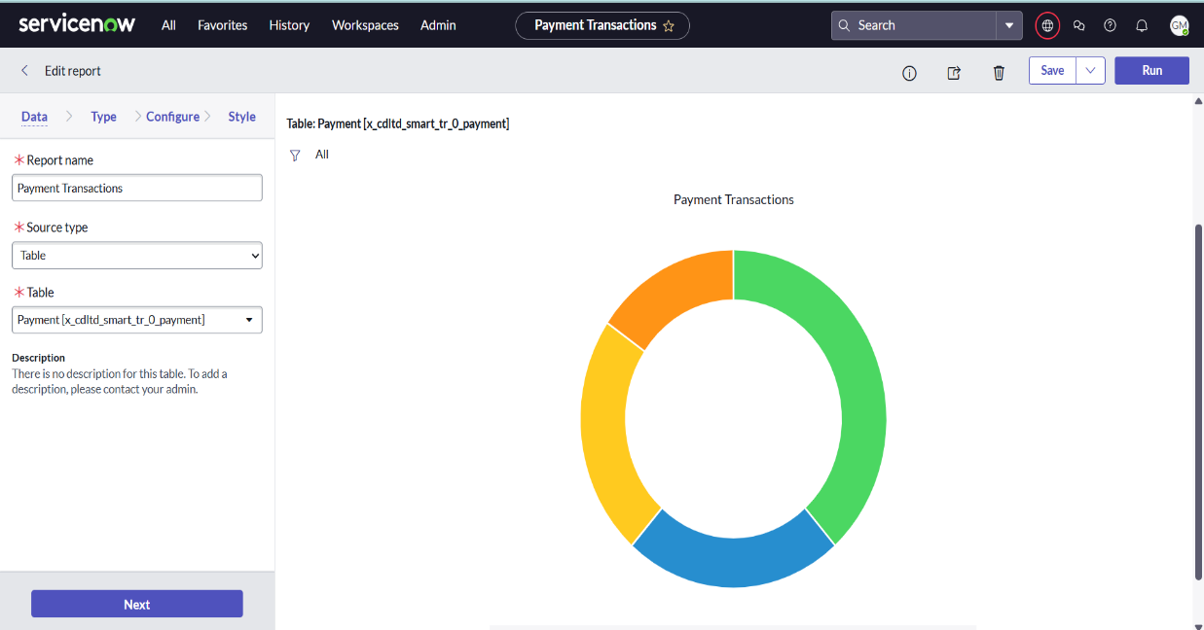

1. Top Routes by Bookings

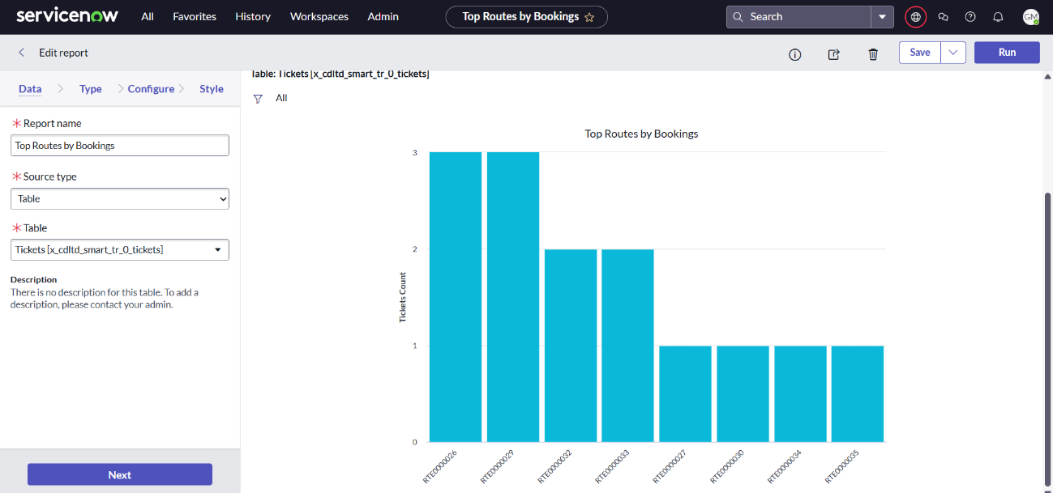

**Milestone 8: Creating Service Catalog**

**Activity 1: Create Catalog**

**Step-1:** Navigate to Servicenow Studio and click on create a file.

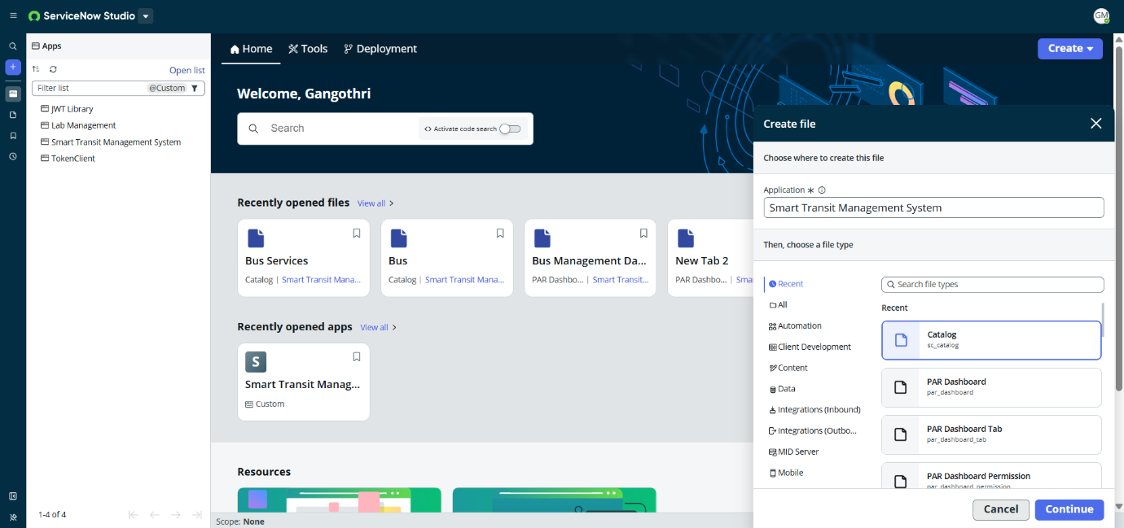

**Step-2:** Choose Application as Smart Transit Management System and file type as Catalog. Enter details as below and save it.

* **Title**: Bus Services
* **Active:** True
* **Enable Wishlist:** True
* **Description:** The Bus Booking, Reporting, Requesting and Cancellation services allow customers to conveniently reserve seats on available buses.
* Desktop image:

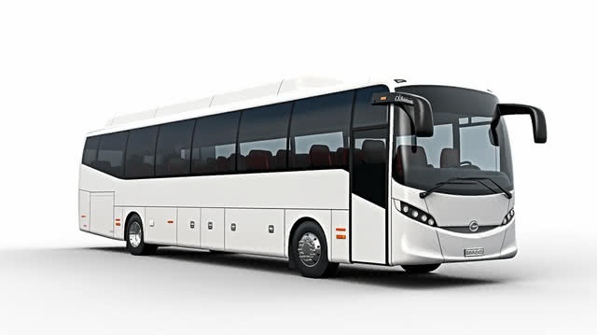

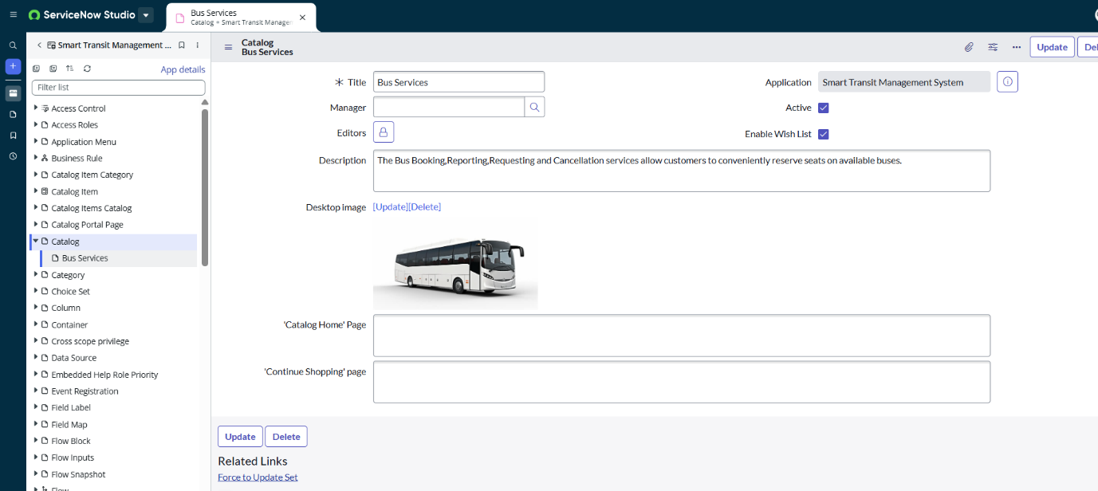

**Activity-2: Create Categories**

**Step-1:** Ensure you are in catalog bus services form. Scroll down to categories pane and click on new.

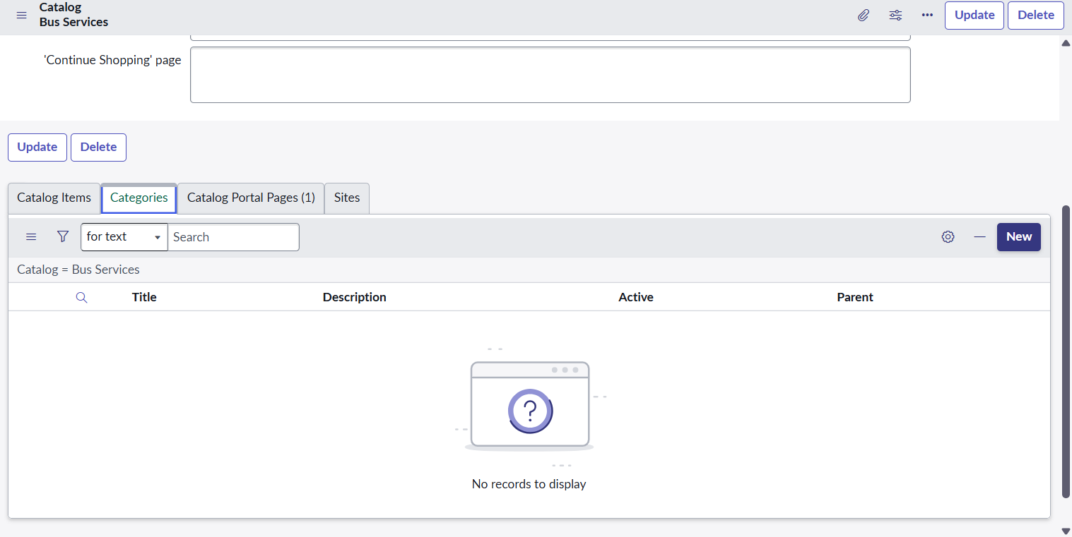

**Step-2:** Populate the form as below for Financial Services and save it.

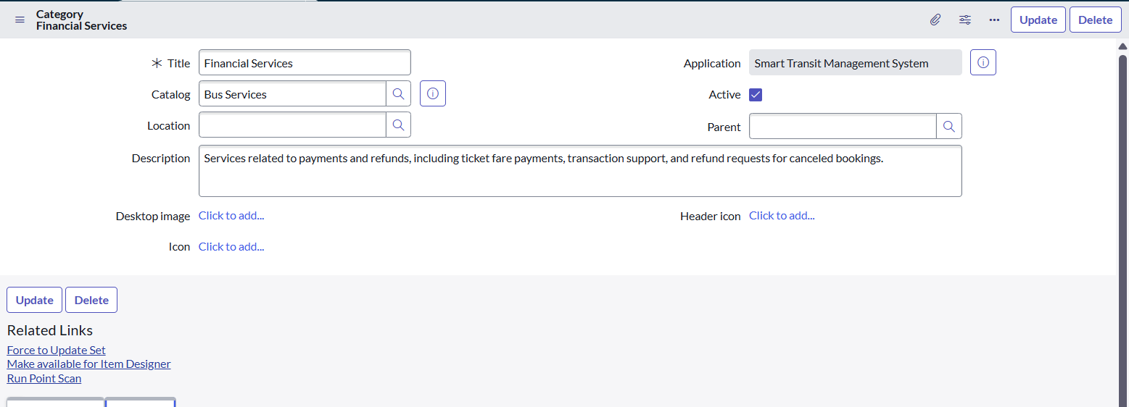

**Step-3:** Repeat Step-2 for Admin Services and Passenger Services Categories.

**Step-4:** Create Catalog items as below:

1.**Name:** Book a Ticket

**Catalogs:** Bus Services

**Category:** Passenger Services

**State:** Published

**Active:** True

**Short description:** Reserve a seat on your preferred bus.

**Description:** Submit details such as bus, date, and passenger information to book your travel ticket.

**Step-5:** Scroll and create variables for Book a Ticket Catalog item as below.

1.**Type:** Single line text

**Catalog item:** Book a Ticket

**Active:** True

**Question:** Please enter your name(customer)...

**Name:** customer_name

**Label:** your name

2.**Type:** Date/Time

**Catalog item:** Book a Ticket

**Active:** True

**Question:** When do you want to travel?

**Name:** travel_date

**Label:** Select travel date

3.**Type:** Lookup Select Box

**Catalog item:** Book a Ticket

**Active:** True

**Question:** Select your bus

**Name:** bus_id

**Label:** Choose bus

4.**Type:** Numeric Scale

**Catalog item:** Book a Ticket

**Active:** True

**Question:** How many seats do you want to book?

**Name:** seats_required

**Label:** Enter seat count

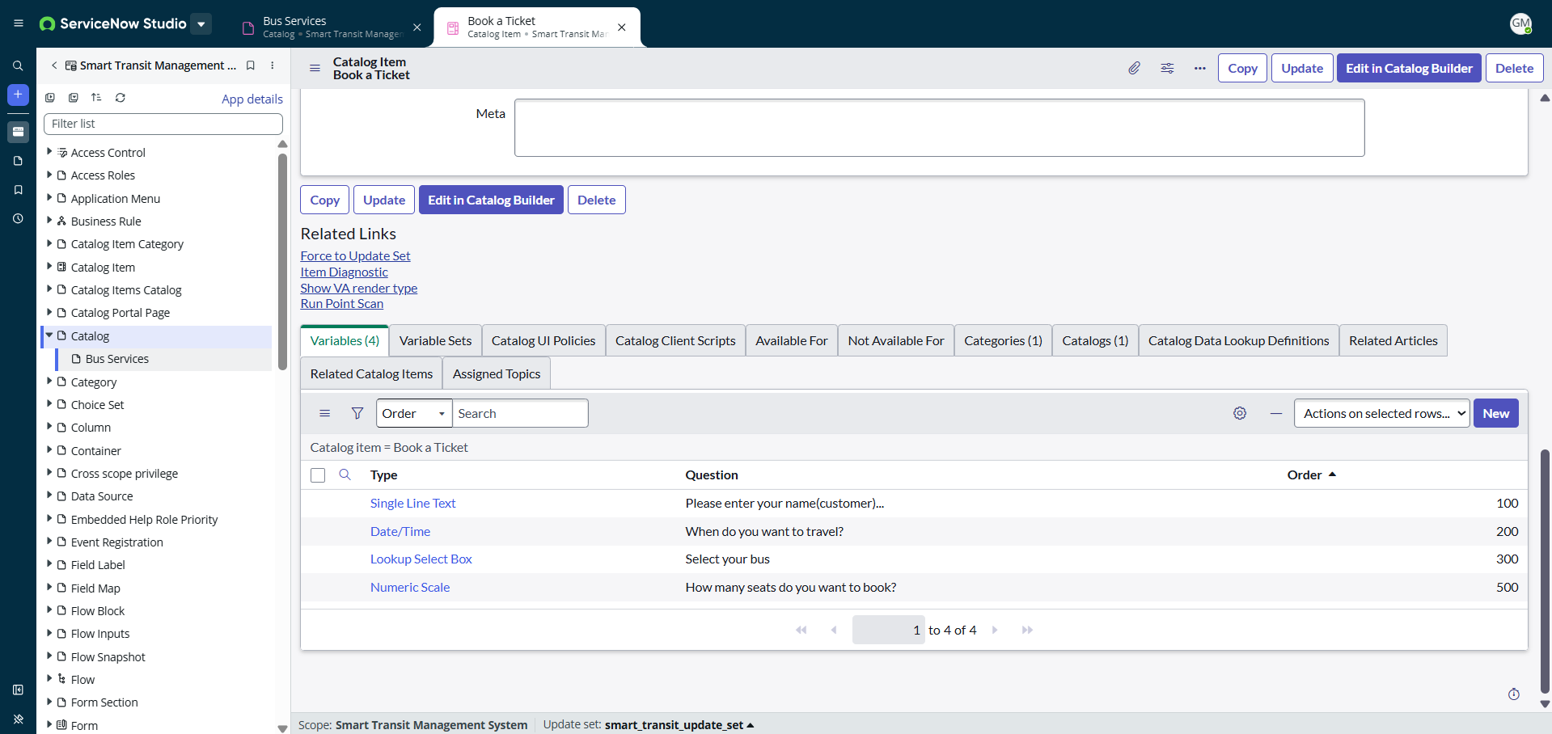

**Step-6:** Create Catalog item: Bus Maintainace Request and Category Admin Services.

**Step-7:** Create variables listed below

1.**Question:** Describe the issue

**Type:** Multiline Text

2.**Question:** Select bus ID

**Type:** Lookup Select Box

3.**Question:** Reported by

**Type:** Single line Text

4.**Question:** Urgency Level

**Type:** Multiple Choice

**Step-8:** Create Catalog item: Cancel item and Category: Passenger Services

Create Variables.

1.**Question:** Enter your Ticket number

**Type:** Single line text

2.**Question:** Reason for cancellation

**Type:** Multi line text

**Step-9:** Create Catalog item: Report Lost Item in Bus and Category: Passenger services

Create Variables.

1. Enter Your name(Single Line Text)
2. Contact details(Single Line Text)
3. Select the bus you have lost item(Lookup Select Box)
4. When did you Travel(Date)
5. Describe the lost item(Multi line text)

**Step-10:** Create Catalog item: Request Refund and Category: Financial Services

Create Variables as below.

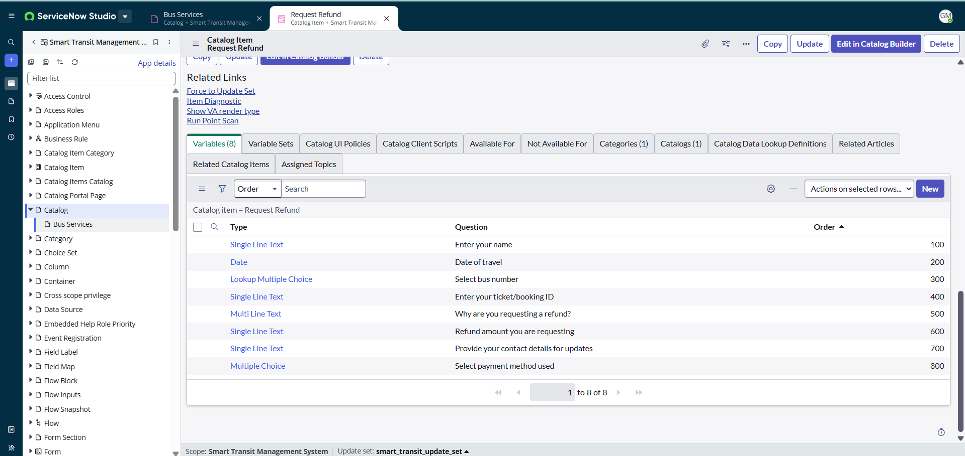

**Step-11:** Update and Click on Activate.

**Step-12:** On Catalog Portal Pages pane, Add portal page: Catalog_bus_services.

**Milestone 9: Booking Summary UI Page**

**Step 1: Page Overview**

* **Page Name:** booking_summary
* **Application:** Smart Transit Management System
* **Category:** General
* **Description:** Custom page to show booking summary.
* **Endpoint:** x_cdlted_smart_tr_0_booking_summary.do

**Step 2: Purpose**

The **Booking Summary UI Page** is designed to provide a visual dashboard that displays real-time booking statistics, available buses, revenue details, and system uptime for administrators and managers.

**Step 3: Navigation Path**

Navigate to:  
**Smart Transit Management → Booking Summary**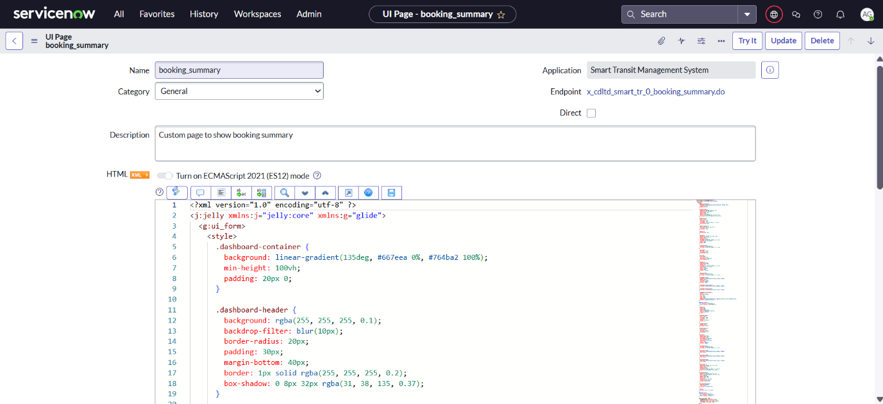

**Step 4: Page Layout**

The page is structured with the following components:

1. **Dashboard Header**
   * Title: *Smart Transit Management*
   * Subtitle: *Comprehensive bus booking and management dashboard*
2. **Key Metrics (Top Counters)**
   * Active Bookings → Shows total current active bookings
   * Available Buses → Displays count of buses available
   * Today’s Revenue → Shows total revenue for the day
   * System Uptime → Displays uptime percentage
3. **Functional Cards (Middle Section)**
   * **Booking Management** → Manage bookings, seat availability, and passenger details
   * **Fleet Management** → Monitor bus locations, schedules, and driver assignments
   * **Revenue Center** → Handle payment processing, fare management, and financial reporting

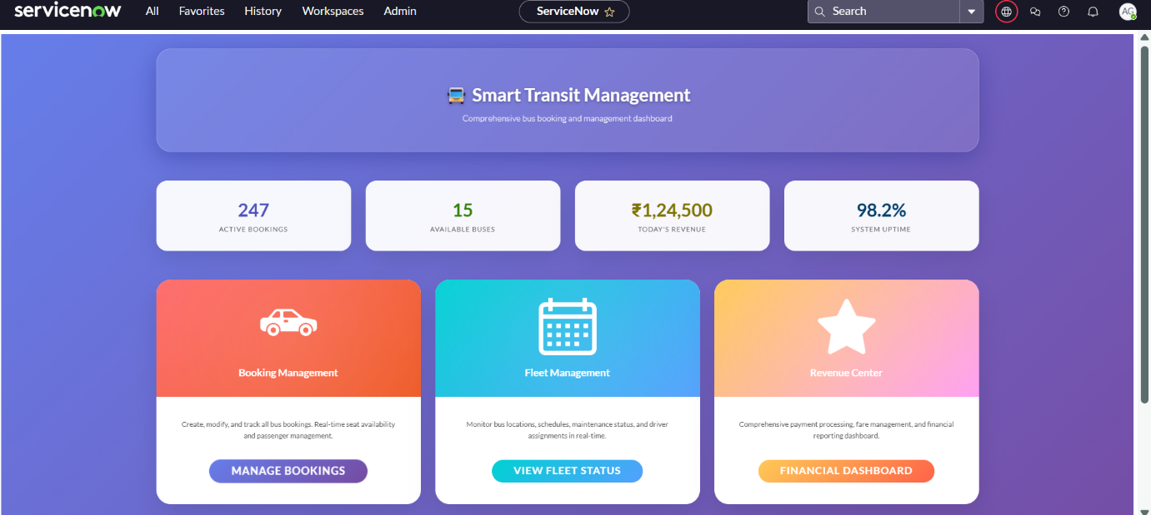

1. **Quick Actions (Bottom Section)**
   * New Booking
   * Add Bus
   * Process Payment
   * View Reports
   * Settings

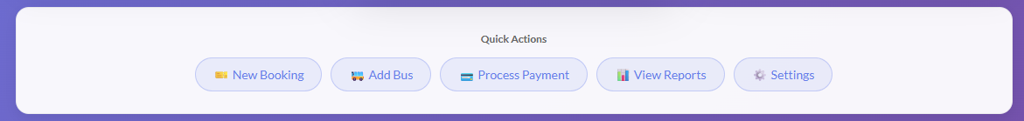

**Step 5: Functionality**

* Displays real-time booking summary data.
* Provides quick navigation to other modules via functional cards.
* Allows users to perform frequent operations directly using quick action buttons.

**Step 6: Data Flow**

1. UI Page is loaded via endpoint.
2. Data such as active bookings, buses, revenue, and uptime are fetched from related tables (Booking, Bus, Payment, System Logs).
3. The data is displayed in summary counters.
4. Clicking on functional cards or quick actions redirects the user to respective modules.

**Step 7: Roles & Permissions**

* **Transit_Admin** → Full access to dashboard.
* **Booking_Manager** → Can view booking summary and manage bookings.
* **Finance_Manager** → Can access revenue and payment actions.

**Step 8: Dependencies**

* Booking table (to fetch active bookings).

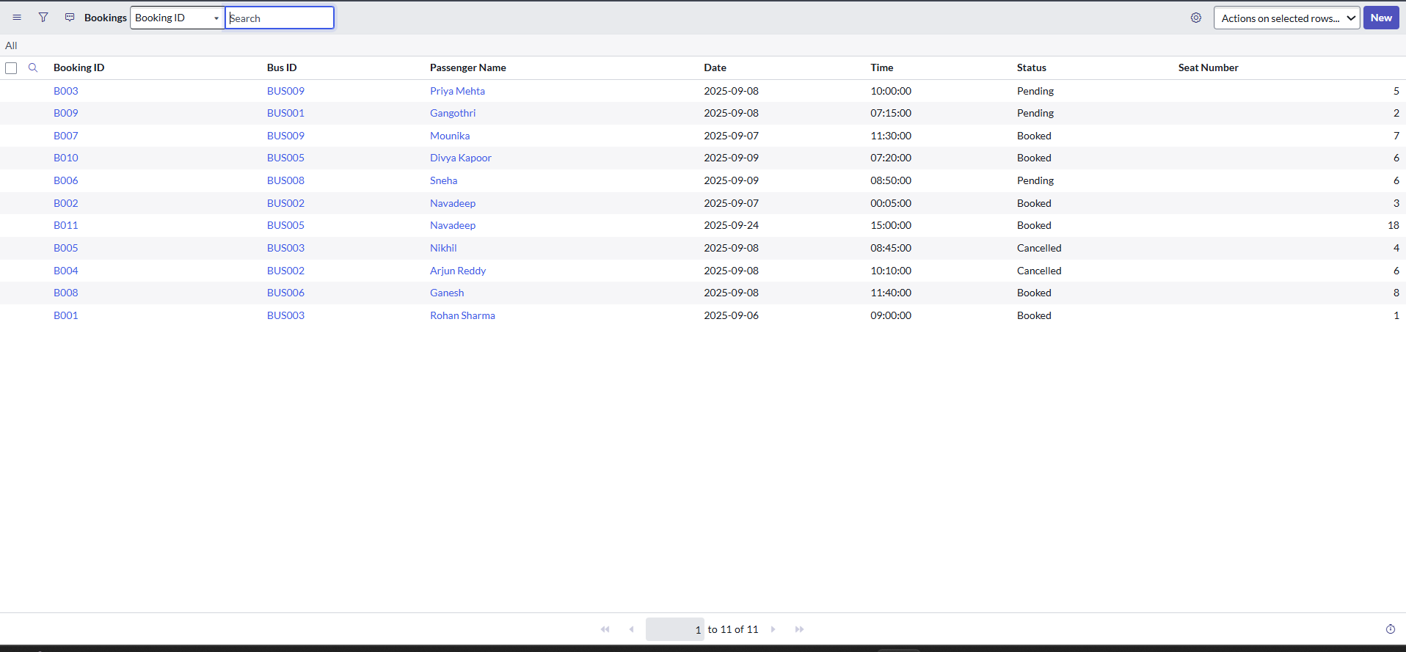

* Bus table (to fetch available buses).

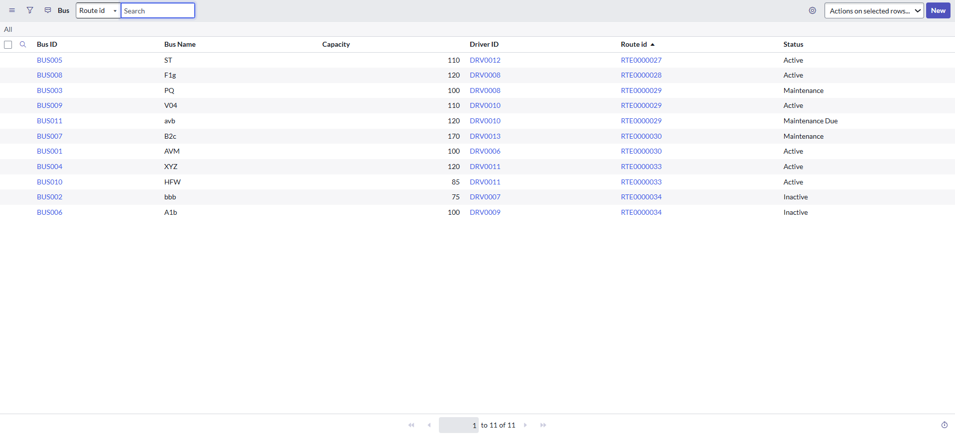

* Payment/Transaction table (for daily revenue).

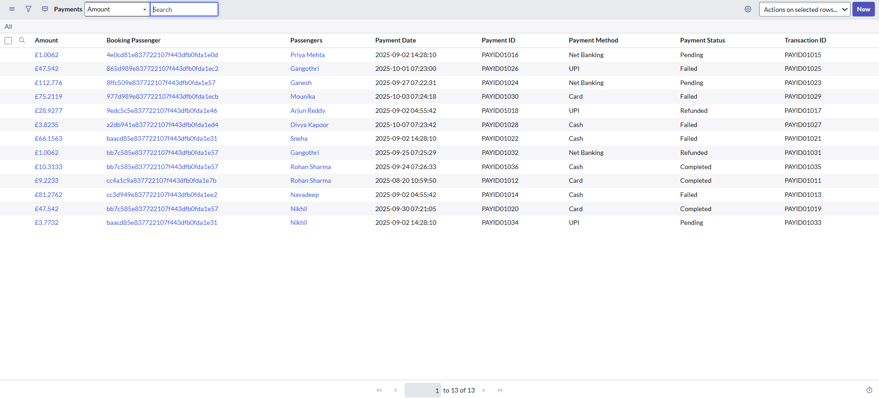

**Step 9: Testing & Validation**

* Verified that booking count updates when new booking is added.
* Confirmed available buses update when a bus is marked inactive.
* Tested that revenue value changes after payment processing.
* Validated quick action buttons redirect correctly to respective modules.

**Step 10: Future Enhancements**

* Add trend charts (e.g., daily/weekly bookings, revenue trends).
* Enable role-based widgets (e.g., Finance view vs Operations view).
* Integrate alerts/notifications for critical events.

**Mile stone 10: Creating Business Rules**

1.Select the **Create** icon [+] and then select **File**.



2.Specify the **Application** the file will belong to: *Smart Transit Management System.*

3.Select **Automation** on the left-side panel.

4.Scroll down and select **Business Rule(sys_script)** as the file type.

5.Select **Continue**.

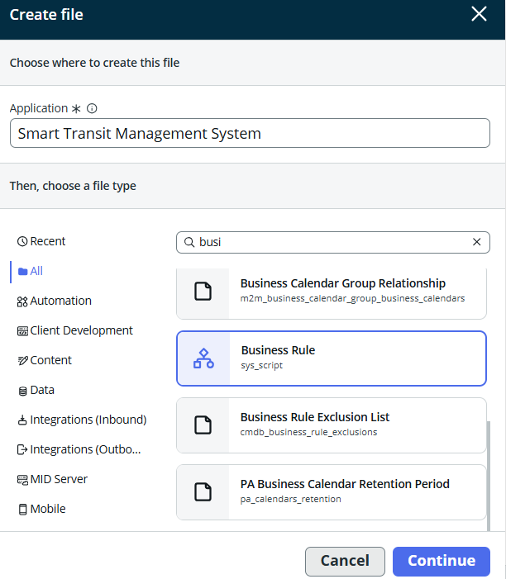

**Activity 1:**

* Name: Auto generate Bus ID  
  Table: Bus[x_cdlt_d_smart_tr_0_bus]
* Select **Advanced**.
* In when to run section
  + When: Beforre
  + Order: 100.
  + Select **Insert.**

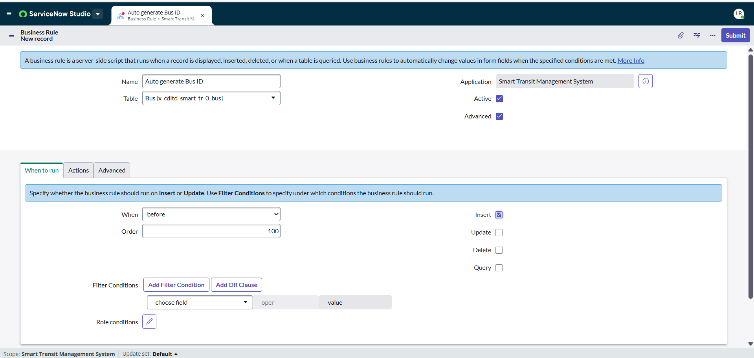

1.In Advanced Section **Add script**.

(function executeRule(current, previous /*null when async*/) {

    var fieldName = 'bus_id';

    var prefix = "BUS";

    if (!current[fieldName]) {

        var gr = new GlideRecord('x_cdltd_smart_tr_0_bus');

        gr.orderByDesc('sys_created_on');

        gr.setLimit(1);

        gr.query();

        var nextNumber = 1;

        if (gr.next()) {

            var lastID = gr[fieldName].toString();

            var numericPart = parseInt(lastID.replace(prefix, ''), 10);

            if (!isNaN(numericPart)) {

                nextNumber = numericPart + 1;

            }

        }

        current[fieldName] = prefix + nextNumber.toString().padStart(3, '0');

    }

})(current, previous);

2.Select **Submit.**

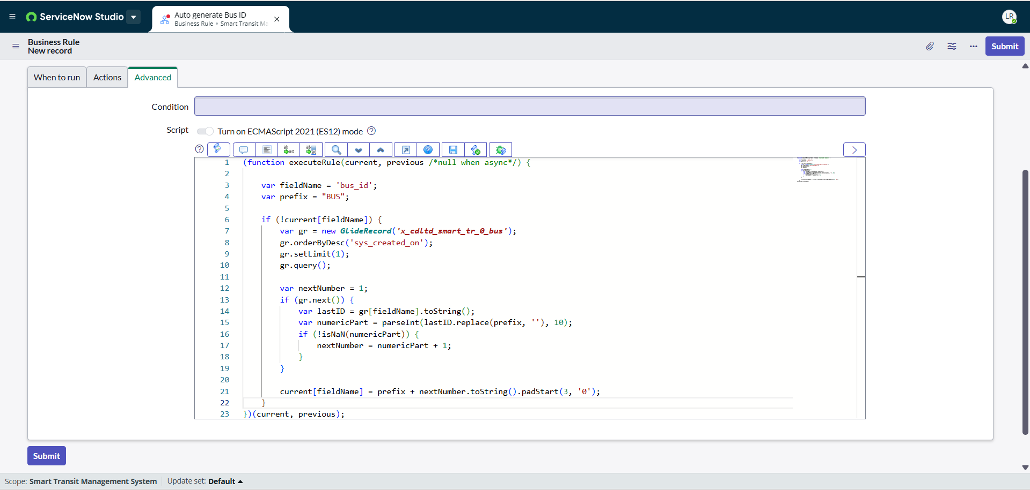

**Activity 2:**

* Name: Set Feedback date  
  Table: Feedback_new[x_cdlt_d_smart_tr_0_bus]
* Select **Advanced**.
* In when to run section
  + When: Beforre
  + Order: 100.
  + Select **Insert.**

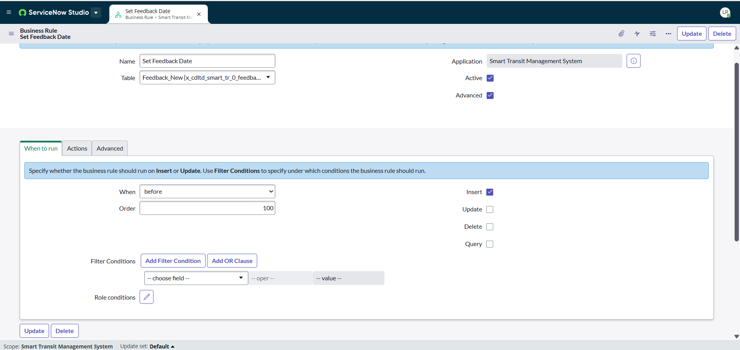

1.In Advanced Section **Add script**.

(function executeRule(current, gSNC, gs) {

    if (!current.feedback_date) {

        current.feedback_date = new GlideDateTime();

    }

})(current, gSNC, gs);

2.Select **Submit**.

**Similarly create business rule for other tables to auto generate id,**

1.Bookings[x_cdlt_d_smart_tr_0_bookings]

2.Route Table[x_cdlt_d_smart_tr_0_route_table]

3.Driver[x_cdlt_d_smart_tr_0_driver]

5.Passenger[x_cdlt_d_smart_tr_0_passenger]

6.Payment[x_cdlt_d_smart_tr_0_payment]

7.Schedule_table[x_cdlt_d_smart_tr_0_schedule_table]

9.Tickets[x_cdlt_d_smart_tr_0_tickets]

**Milestone 11: Knowledge Base**

**1. Accessing the Knowledge Base**

**Step 1:** Log in to the **Smart Transit Management System Portal**.  
**Step 2:** From the homepage, click on **Knowledge Search**.  
**Step 3:** In the search bar, enter at least **3 characters** of your query.  
**Step 4:** Click on **Filters** and select the required category:

* Admin & Operations
* Driver Support
* Passenger Support

**Step 5:** Click on the desired article title to open and view full details.

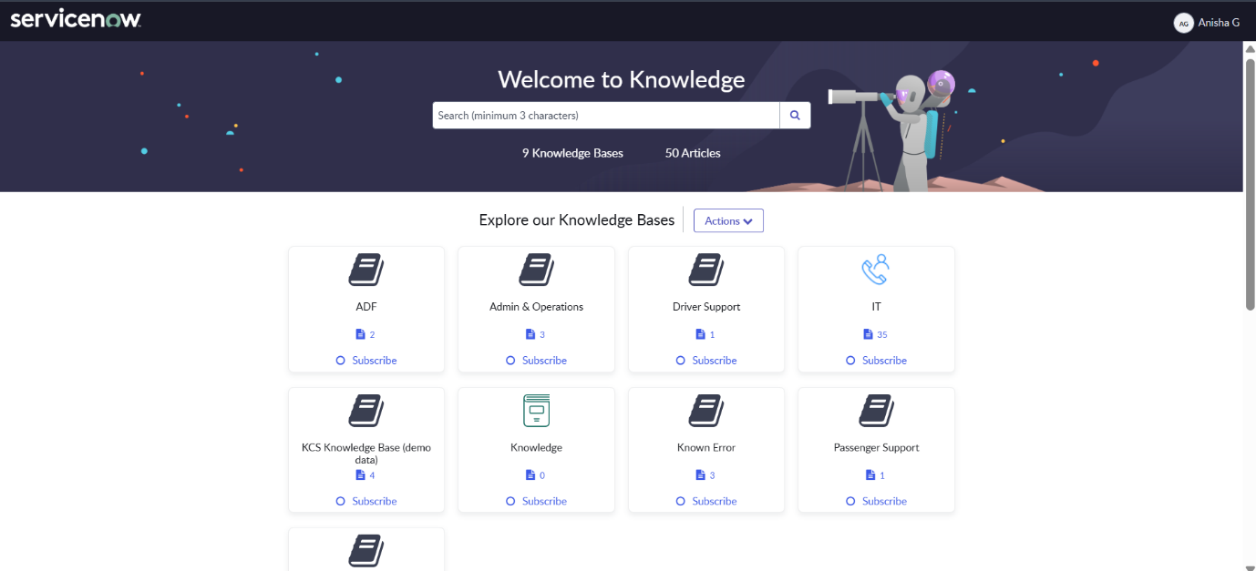

**2. Admin & Operations Knowledge Articles**

**(a) How to Add, Remove, or Update a Driver**

**Step 1:** Log in to the **Admin Portal**.  
**Step 2:** Navigate to **Admin Dashboard → Driver Management → Add Driver**.  
**Step 3:** Enter driver details (Name, Driver ID, Contact, Vehicle).  
**Step 4:** Save the record to complete driver addition.  
**Step 5:** To update or remove, select the driver record and perform the required action.

**(b) How to Generate Weekly or Monthly Reports**

**Step 1:** Log in to the **Admin Portal**.  
**Step 2:** Navigate to **Admin Dashboard → Reports**.  
**Step 3:** Choose **Weekly Report** or **Monthly Report**.  
**Step 4:** Generate the report and download/export if needed.

**(c) How to Schedule and Manage Routes**

**Step 1:** Log in to the **Operations Portal**.  
**Step 2:** Navigate to **Dashboard → Routes → Manage Routes**.  
**Step 3:** Click **Add Route**.  
**Step 4:** Enter route details (Start Point, End Point, Time, Driver).  
**Step 5:** Save changes.  
**Step 6:** Use **Edit/Delete** to manage existing routes.

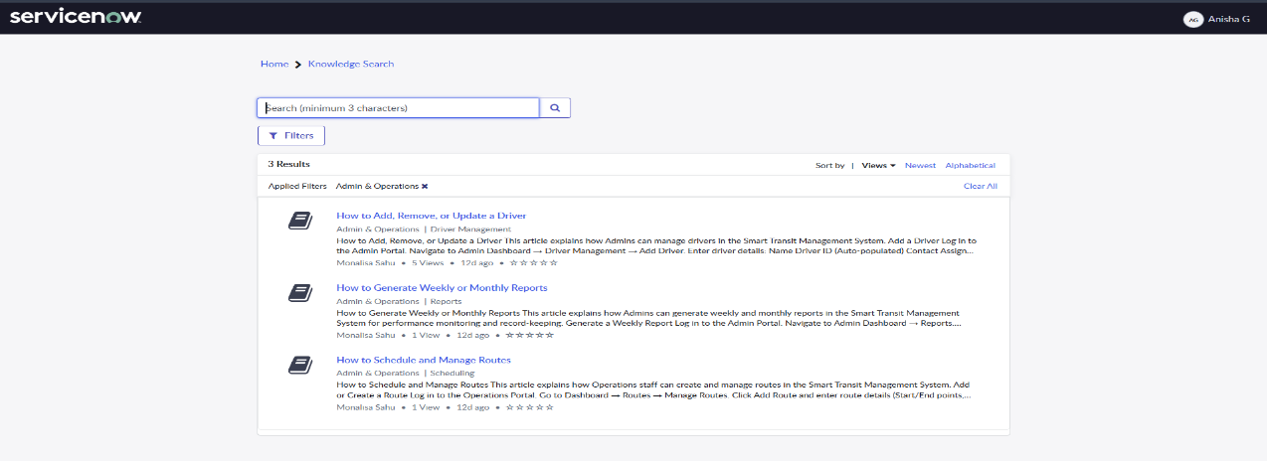

**3. Driver Support Knowledge Articles**

**(a) Guides and Resources for Drivers – How to Check Assigned Routes**

**Step 1:** Open the **Smart Transit Mobile App**.  
**Step 2:** Log in and go to **Driver Dashboard**.  
**Step 3:** Click on **My Routes**.  
**Step 4:** Select the **date**.  
**Step 5:** View assigned route details:

* Start & Destination Points
* Scheduled Time
* Vehicle Number
* Assigned Passengers

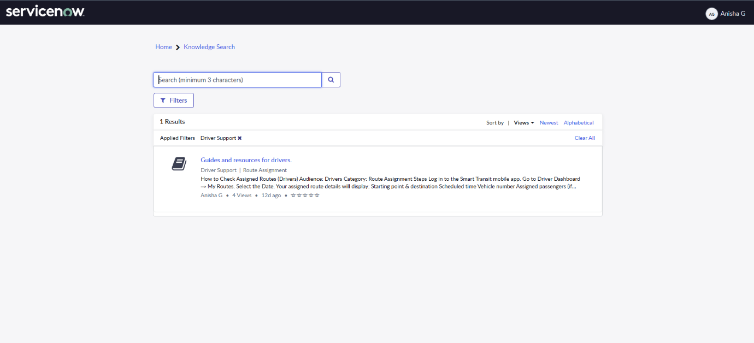

**4. Passenger Support Knowledge Articles**

**(a) How to Book a Bus Ticket**

**Step 1:** Open the **Smart Transit Web Portal**.  
**Step 2:** Sign in or continue as **Guest**.  
**Step 3:** Enter trip details – From, To, Date, Time, Number of Passengers.  
**Step 4:** Click **Search**.  
**Step 5:** Select the desired bus from results.  
**Step 6:** Confirm booking details.  
**Step 7:** Proceed to **payment** and confirm ticket.

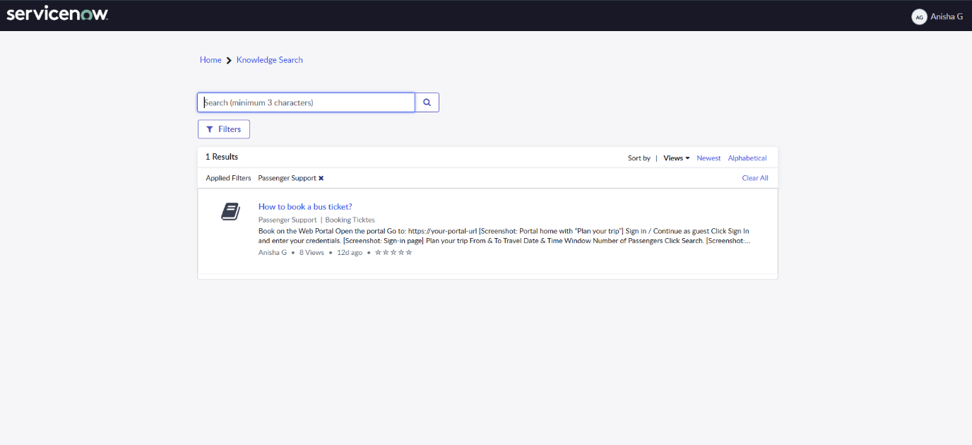

**Milestone 12: Dashboards**

**Activity 1: Bus Management Dashboard**

**Step-1:** Navigate to All > Dashboards and Click on Create dashboard.

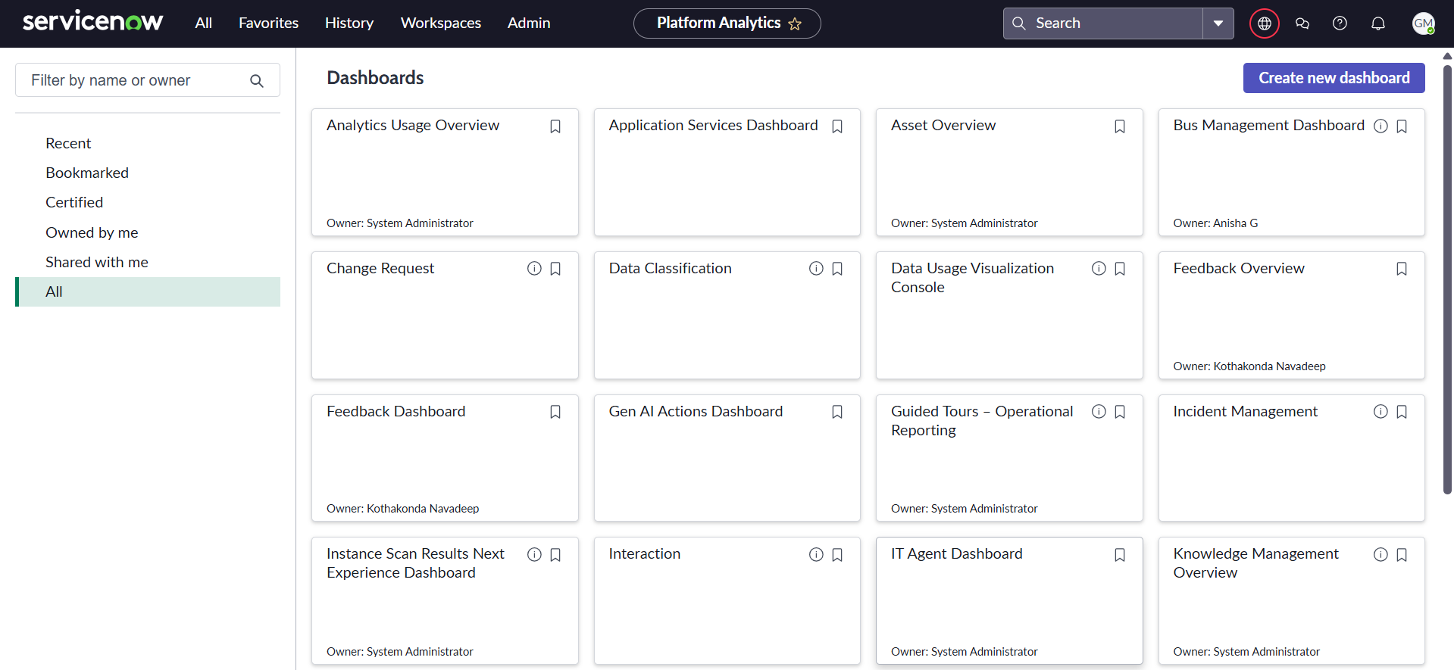

**Step-2:** Enter name : Bus Management Dashboard and click Create new dashboard.

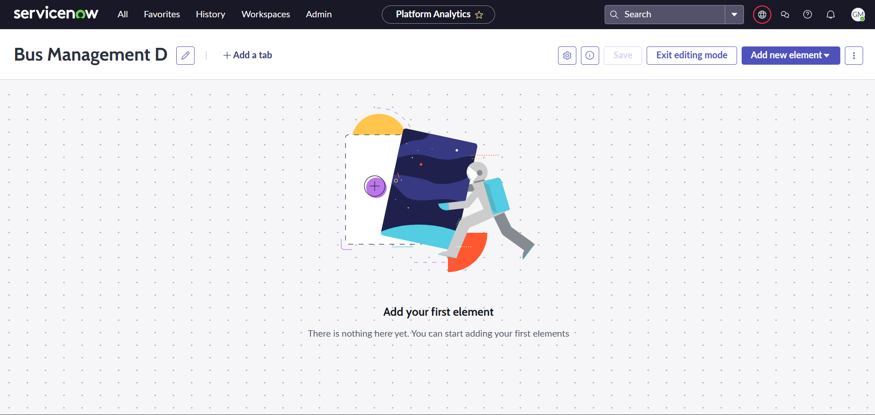

**Step-3:** Click on Add new element and select data visualization then new visualization.

On configuration pane, Add data source as bus table.

Visualization type: Donut

Chart title: Active vs Maintanence vs idle

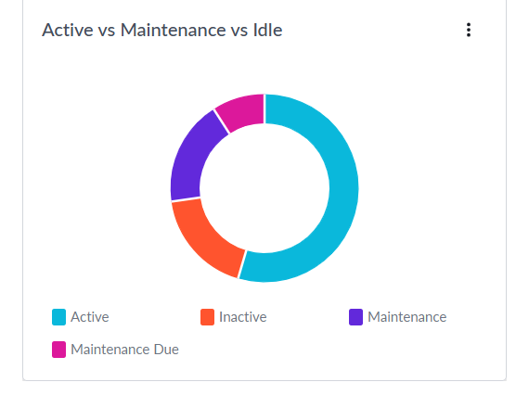

**Step-4:** Click on Add new element to add Buses by route Barchart. Proceed same as above step. Group by : Route.

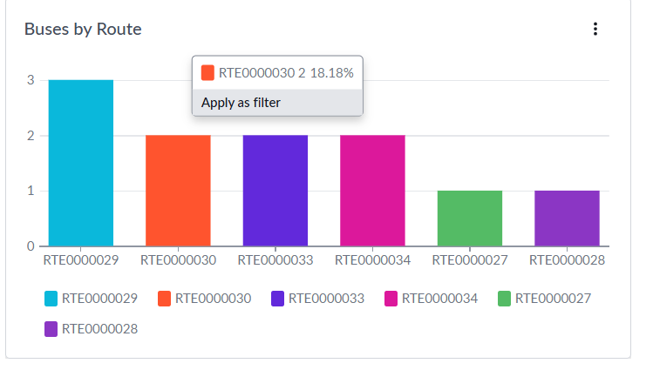

**Step-5:** Again click on add new element for Driver performance metrics using table: Drivers.

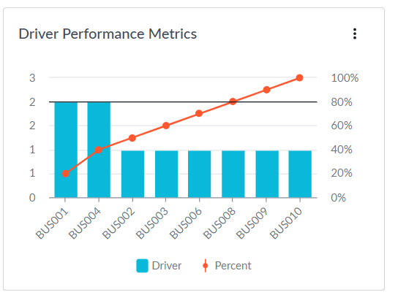

**Step-6:** Save changes.

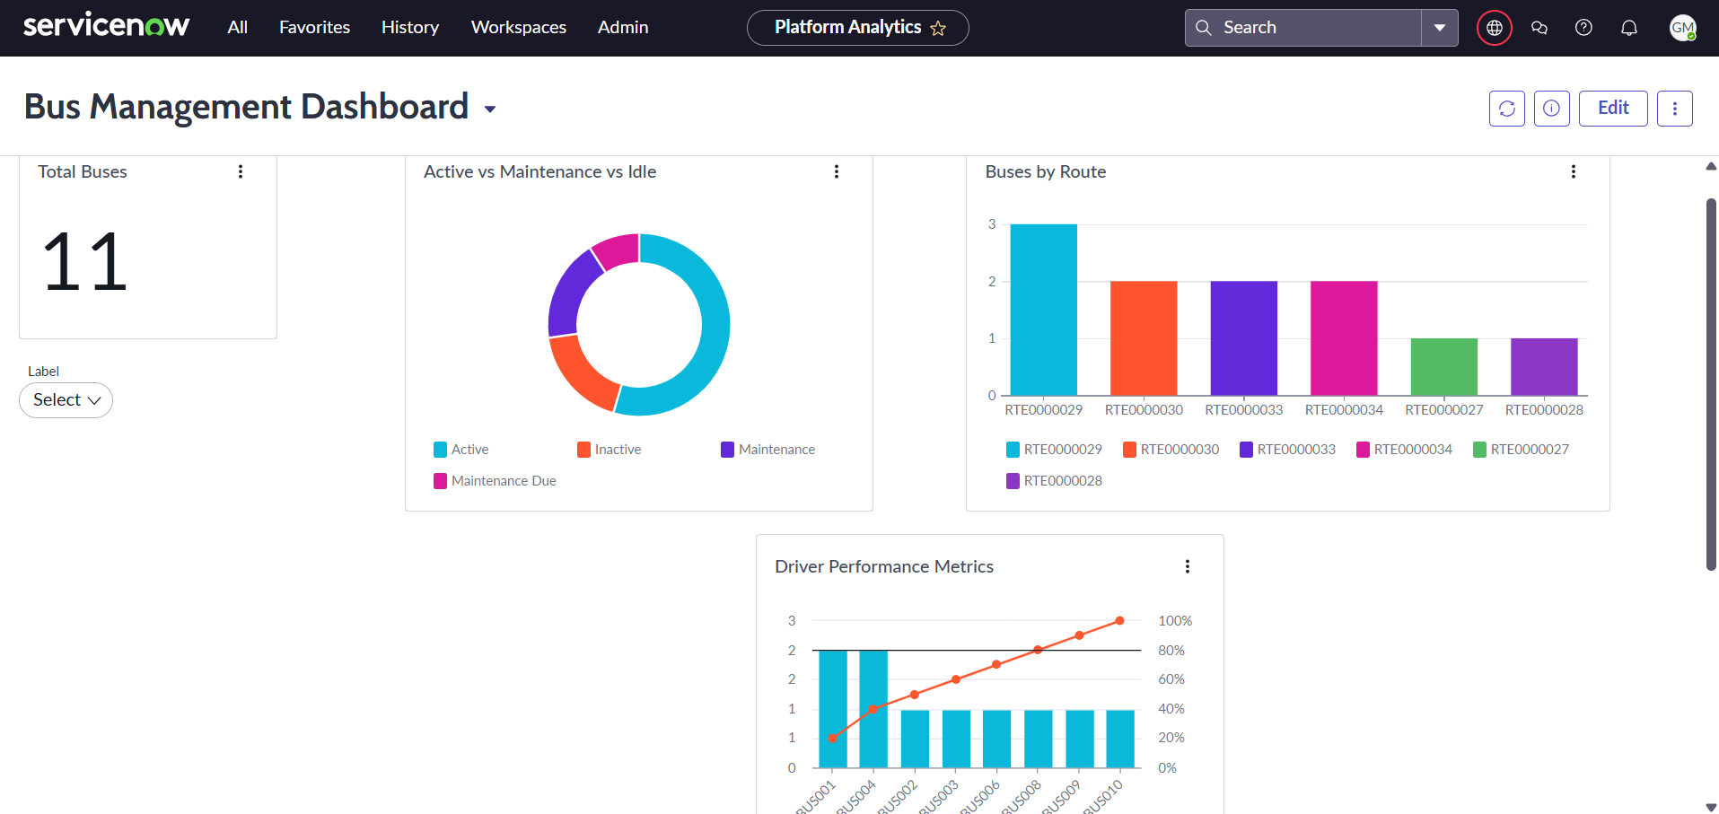

**Activity-2: Feedback Dashboard**

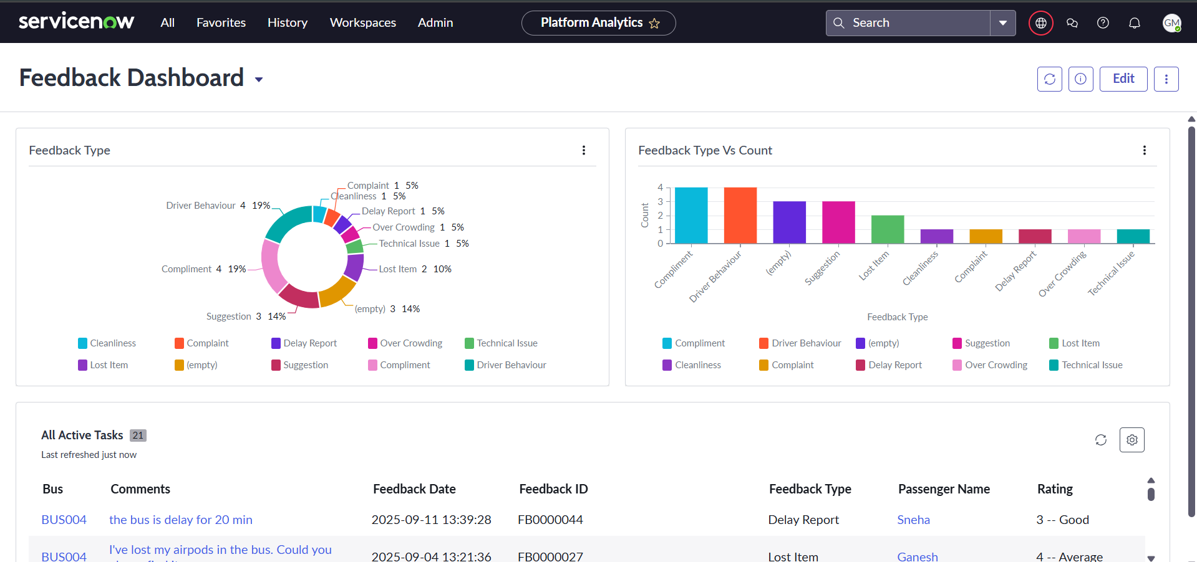

**Activity-3: Payments Dashboard**

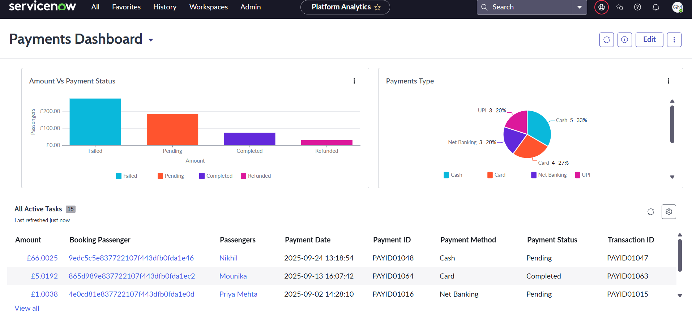

**Activity-4: Routes Dashboard**

